1 run......

training 1 epoch...

10.589580297470093 seconds used......

1 training finished! average train loss: 0.7057006088586953

evaluating...

Confusion matrix, without normalization

[[ 0 0 41]

[ 0 0 95]

[ 0 0 714]]

Normalized confusion matrix

[[0. 0. 1.]

[0. 0. 1.]

[0. 0. 1.]]

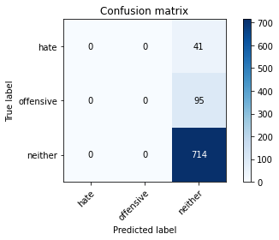

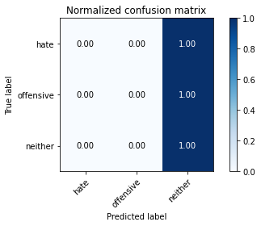

/opt/conda/lib/python3.7/site-packages/sklearn/metrics/_classification.py:1245: UndefinedMetricWarning: Precision and F-score are ill-defined and being set to 0.0 in labels with no predicted samples. Use `zero_division` parameter to control this behavior.

_warn_prf(average, modifier, msg_start, len(result))

/opt/conda/lib/python3.7/site-packages/sklearn/metrics/_classification.py:1245: UndefinedMetricWarning: Precision and F-score are ill-defined and being set to 0.0 in labels with no predicted samples. Use `zero_division` parameter to control this behavior.

_warn_prf(average, modifier, msg_start, len(result))

/opt/conda/lib/python3.7/site-packages/sklearn/metrics/_classification.py:1245: UndefinedMetricWarning: Precision and F-score are ill-defined and being set to 0.0 in labels with no predicted samples. Use `zero_division` parameter to control this behavior.

_warn_prf(average, modifier, msg_start, len(result))

precision recall f1-score support

hate 0.00 0.00 0.00 41

offensive 0.00 0.00 0.00 95

neither 0.84 1.00 0.91 714

accuracy 0.84 850

macro avg 0.28 0.33 0.30 850

weighted avg 0.71 0.84 0.77 850

average eval_loss: 0.4692128425420717, accuracy: 0.84

training 2 epoch...

10.533540964126587 seconds used......

2 training finished! average train loss: 0.5881418147912392

evaluating...

Confusion matrix, without normalization

[[ 14 0 27]

[ 11 0 84]

[ 35 0 679]]

Normalized confusion matrix

[[0.34146341 0. 0.65853659]

[0.11578947 0. 0.88421053]

[0.04901961 0. 0.95098039]]

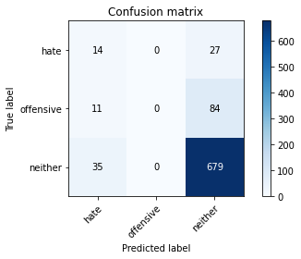

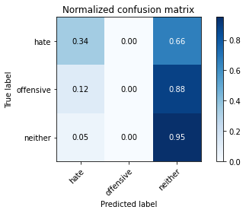

/opt/conda/lib/python3.7/site-packages/sklearn/metrics/_classification.py:1245: UndefinedMetricWarning: Precision and F-score are ill-defined and being set to 0.0 in labels with no predicted samples. Use `zero_division` parameter to control this behavior.

_warn_prf(average, modifier, msg_start, len(result))

/opt/conda/lib/python3.7/site-packages/sklearn/metrics/_classification.py:1245: UndefinedMetricWarning: Precision and F-score are ill-defined and being set to 0.0 in labels with no predicted samples. Use `zero_division` parameter to control this behavior.

_warn_prf(average, modifier, msg_start, len(result))

/opt/conda/lib/python3.7/site-packages/sklearn/metrics/_classification.py:1245: UndefinedMetricWarning: Precision and F-score are ill-defined and being set to 0.0 in labels with no predicted samples. Use `zero_division` parameter to control this behavior.

_warn_prf(average, modifier, msg_start, len(result))

precision recall f1-score support

hate 0.23 0.34 0.28 41

offensive 0.00 0.00 0.00 95

neither 0.86 0.95 0.90 714

accuracy 0.82 850

macro avg 0.36 0.43 0.39 850

weighted avg 0.73 0.82 0.77 850

average eval_loss: 0.5324824176901994, accuracy: 0.8152941176470588

training 3 epoch...

10.565226793289185 seconds used......

3 training finished! average train loss: 0.4424991570986234

evaluating...

Confusion matrix, without normalization

[[ 6 0 35]

[ 2 0 93]

[ 10 0 704]]

Normalized confusion matrix

[[0.14634146 0. 0.85365854]

[0.02105263 0. 0.97894737]

[0.0140056 0. 0.9859944 ]]

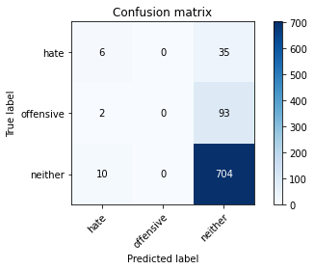

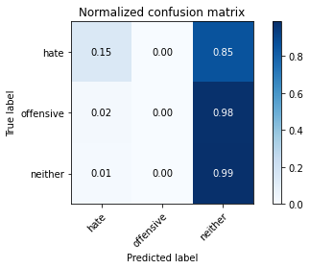

/opt/conda/lib/python3.7/site-packages/sklearn/metrics/_classification.py:1245: UndefinedMetricWarning: Precision and F-score are ill-defined and being set to 0.0 in labels with no predicted samples. Use `zero_division` parameter to control this behavior.

_warn_prf(average, modifier, msg_start, len(result))

/opt/conda/lib/python3.7/site-packages/sklearn/metrics/_classification.py:1245: UndefinedMetricWarning: Precision and F-score are ill-defined and being set to 0.0 in labels with no predicted samples. Use `zero_division` parameter to control this behavior.

_warn_prf(average, modifier, msg_start, len(result))

/opt/conda/lib/python3.7/site-packages/sklearn/metrics/_classification.py:1245: UndefinedMetricWarning: Precision and F-score are ill-defined and being set to 0.0 in labels with no predicted samples. Use `zero_division` parameter to control this behavior.

_warn_prf(average, modifier, msg_start, len(result))

precision recall f1-score support

hate 0.33 0.15 0.20 41

offensive 0.00 0.00 0.00 95

neither 0.85 0.99 0.91 714

accuracy 0.84 850

macro avg 0.39 0.38 0.37 850

weighted avg 0.73 0.84 0.77 850

average eval_loss: 0.42707606994135433, accuracy: 0.8352941176470589

training 4 epoch...

10.557382583618164 seconds used......

4 training finished! average train loss: 0.3015237643168523

evaluating...

Confusion matrix, without normalization

[[ 19 0 22]

[ 24 9 62]

[ 73 14 627]]

Normalized confusion matrix

[[0.46341463 0. 0.53658537]

[0.25263158 0.09473684 0.65263158]

[0.1022409 0.01960784 0.87815126]]

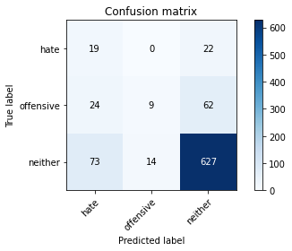

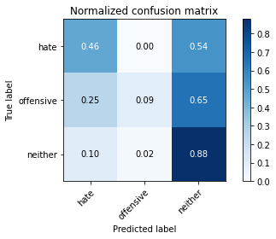

precision recall f1-score support

hate 0.16 0.46 0.24 41

offensive 0.39 0.09 0.15 95

neither 0.88 0.88 0.88 714

accuracy 0.77 850

macro avg 0.48 0.48 0.42 850

weighted avg 0.79 0.77 0.77 850

average eval_loss: 0.5198449756257063, accuracy: 0.7705882352941177

training 5 epoch...

10.64530873298645 seconds used......

5 training finished! average train loss: 0.16568110275727052

evaluating...

Confusion matrix, without normalization

[[ 8 3 30]

[ 5 11 79]

[ 24 19 671]]

Normalized confusion matrix

[[0.19512195 0.07317073 0.73170732]

[0.05263158 0.11578947 0.83157895]

[0.03361345 0.02661064 0.93977591]]

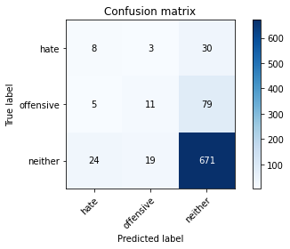

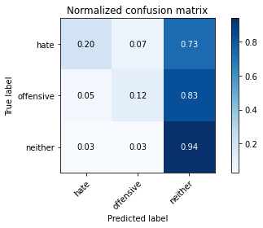

precision recall f1-score support

hate 0.22 0.20 0.21 41

offensive 0.33 0.12 0.17 95

neither 0.86 0.94 0.90 714

accuracy 0.81 850

macro avg 0.47 0.42 0.43 850

weighted avg 0.77 0.81 0.78 850

average eval_loss: 0.5468073816764233, accuracy: 0.8117647058823529

training 6 epoch...

10.667953252792358 seconds used......

6 training finished! average train loss: 0.083584994622148

evaluating...

Confusion matrix, without normalization

[[ 9 10 22]

[ 8 34 53]

[ 26 79 609]]

Normalized confusion matrix

[[0.2195122 0.24390244 0.53658537]

[0.08421053 0.35789474 0.55789474]

[0.03641457 0.11064426 0.85294118]]

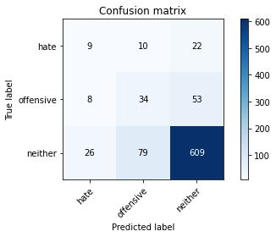

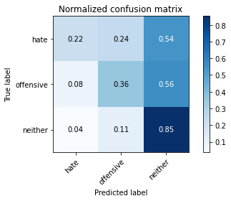

precision recall f1-score support

hate 0.21 0.22 0.21 41

offensive 0.28 0.36 0.31 95

neither 0.89 0.85 0.87 714

accuracy 0.77 850

macro avg 0.46 0.48 0.47 850

weighted avg 0.79 0.77 0.78 850

average eval_loss: 0.7139868075948556, accuracy: 0.7670588235294118

training 7 epoch...

10.56344223022461 seconds used......

7 training finished! average train loss: 0.04246321115642786

evaluating...

Confusion matrix, without normalization

[[ 4 7 30]

[ 4 27 64]

[ 15 59 640]]

Normalized confusion matrix

[[0.09756098 0.17073171 0.73170732]

[0.04210526 0.28421053 0.67368421]

[0.0210084 0.08263305 0.89635854]]

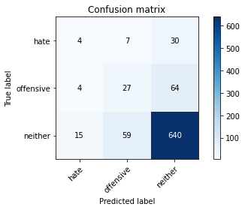

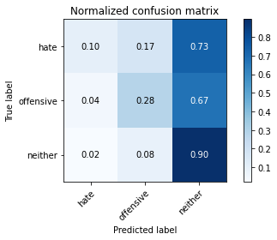

precision recall f1-score support

hate 0.17 0.10 0.13 41

offensive 0.29 0.28 0.29 95

neither 0.87 0.90 0.88 714

accuracy 0.79 850

macro avg 0.45 0.43 0.43 850

weighted avg 0.77 0.79 0.78 850

average eval_loss: 0.7279162383976739, accuracy: 0.7894117647058824

training 8 epoch...

10.664639711380005 seconds used......

8 training finished! average train loss: 0.020884825475513936

evaluating...

Confusion matrix, without normalization

[[ 8 18 15]

[ 9 52 34]

[ 22 120 572]]

Normalized confusion matrix

[[0.19512195 0.43902439 0.36585366]

[0.09473684 0.54736842 0.35789474]

[0.03081232 0.16806723 0.80112045]]

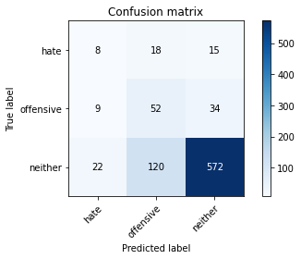

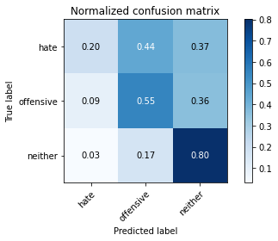

precision recall f1-score support

hate 0.21 0.20 0.20 41

offensive 0.27 0.55 0.36 95

neither 0.92 0.80 0.86 714

accuracy 0.74 850

macro avg 0.47 0.51 0.47 850

weighted avg 0.81 0.74 0.77 850

average eval_loss: 0.9822618997260538, accuracy: 0.7435294117647059

training 9 epoch...

10.574166774749756 seconds used......

9 training finished! average train loss: 0.010723898520406621

evaluating...

Confusion matrix, without normalization

[[ 1 21 19]

[ 3 57 35]

[ 3 136 575]]

Normalized confusion matrix

[[0.02439024 0.51219512 0.46341463]

[0.03157895 0.6 0.36842105]

[0.00420168 0.19047619 0.80532213]]

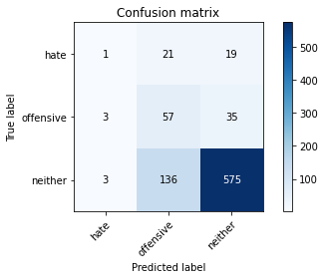

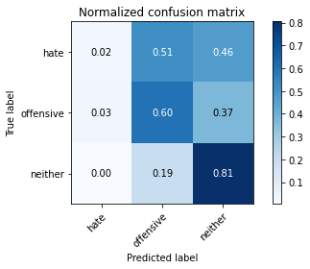

precision recall f1-score support

hate 0.14 0.02 0.04 41

offensive 0.27 0.60 0.37 95

neither 0.91 0.81 0.86 714

accuracy 0.74 850

macro avg 0.44 0.48 0.42 850

weighted avg 0.80 0.74 0.76 850

average eval_loss: 1.138201905178924, accuracy: 0.7447058823529412

training 10 epoch...

10.628180503845215 seconds used......

10 training finished! average train loss: 0.005355993487263242

evaluating...

Confusion matrix, without normalization

[[ 1 22 18]

[ 4 44 47]

[ 5 135 574]]

Normalized confusion matrix

[[0.02439024 0.53658537 0.43902439]

[0.04210526 0.46315789 0.49473684]

[0.0070028 0.18907563 0.80392157]]

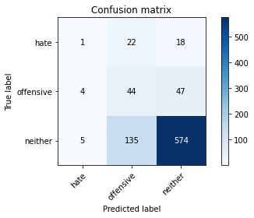

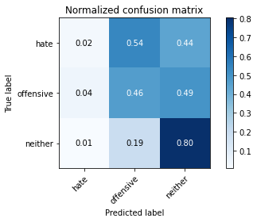

precision recall f1-score support

hate 0.10 0.02 0.04 41

offensive 0.22 0.46 0.30 95

neither 0.90 0.80 0.85 714

accuracy 0.73 850

macro avg 0.41 0.43 0.39 850

weighted avg 0.78 0.73 0.75 850

average eval_loss: 1.186795000563549, accuracy: 0.7282352941176471

training 11 epoch...

10.587901830673218 seconds used......

11 training finished! average train loss: 0.003303549425282444

evaluating...

Confusion matrix, without normalization

[[ 5 17 19]

[ 4 47 44]

[ 7 131 576]]

Normalized confusion matrix

[[0.12195122 0.41463415 0.46341463]

[0.04210526 0.49473684 0.46315789]

[0.00980392 0.18347339 0.80672269]]

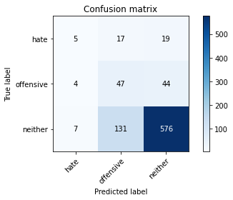

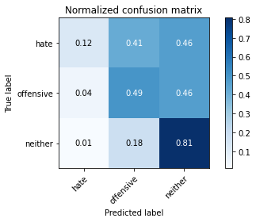

precision recall f1-score support

hate 0.31 0.12 0.18 41

offensive 0.24 0.49 0.32 95

neither 0.90 0.81 0.85 714

accuracy 0.74 850

macro avg 0.48 0.47 0.45 850

weighted avg 0.80 0.74 0.76 850

average eval_loss: 1.2196714663350152, accuracy: 0.7388235294117647

training 12 epoch...

10.591042280197144 seconds used......

12 training finished! average train loss: 0.002520650531648873

evaluating...

Confusion matrix, without normalization

[[ 6 17 18]

[ 4 46 45]

[ 8 124 582]]

Normalized confusion matrix

[[0.14634146 0.41463415 0.43902439]

[0.04210526 0.48421053 0.47368421]

[0.01120448 0.17366947 0.81512605]]

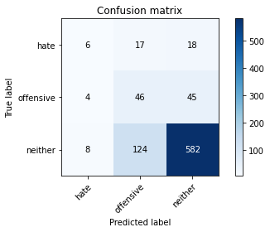

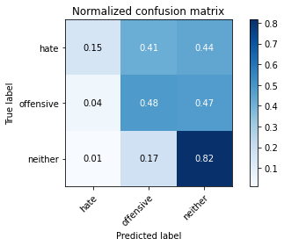

precision recall f1-score support

hate 0.33 0.15 0.20 41

offensive 0.25 0.48 0.33 95

neither 0.90 0.82 0.86 714

accuracy 0.75 850

macro avg 0.49 0.48 0.46 850

weighted avg 0.80 0.75 0.77 850

average eval_loss: 1.2538369602759283, accuracy: 0.7458823529411764

training 13 epoch...

10.575165510177612 seconds used......

13 training finished! average train loss: 0.0025120630390189874

evaluating...

Confusion matrix, without normalization

[[ 1 16 24]

[ 2 36 57]

[ 6 93 615]]

Normalized confusion matrix

[[0.02439024 0.3902439 0.58536585]

[0.02105263 0.37894737 0.6 ]

[0.00840336 0.1302521 0.86134454]]

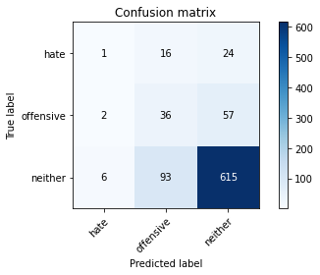

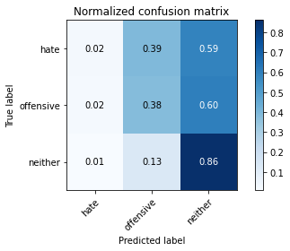

precision recall f1-score support

hate 0.11 0.02 0.04 41

offensive 0.25 0.38 0.30 95

neither 0.88 0.86 0.87 714

accuracy 0.77 850

macro avg 0.41 0.42 0.40 850

weighted avg 0.78 0.77 0.77 850

average eval_loss: 1.1937701470806767, accuracy: 0.7670588235294118

training 14 epoch...

10.524395227432251 seconds used......

14 training finished! average train loss: 0.005198145432111162

evaluating...

Confusion matrix, without normalization

[[ 5 15 21]

[ 5 41 49]

[ 9 99 606]]

Normalized confusion matrix

[[0.12195122 0.36585366 0.51219512]

[0.05263158 0.43157895 0.51578947]

[0.01260504 0.13865546 0.8487395 ]]

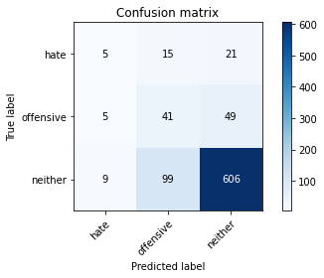

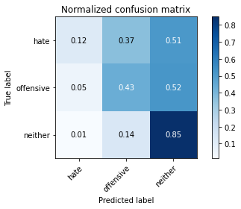

precision recall f1-score support

hate 0.26 0.12 0.17 41

offensive 0.26 0.43 0.33 95

neither 0.90 0.85 0.87 714

accuracy 0.77 850

macro avg 0.47 0.47 0.46 850

weighted avg 0.80 0.77 0.78 850

average eval_loss: 1.1188250280731238, accuracy: 0.7670588235294118

training 15 epoch...

10.611344575881958 seconds used......

15 training finished! average train loss: 0.0034854943570770468

evaluating...

Confusion matrix, without normalization

[[ 4 21 16]

[ 2 62 31]

[ 6 166 542]]

Normalized confusion matrix

[[0.09756098 0.51219512 0.3902439 ]

[0.02105263 0.65263158 0.32631579]

[0.00840336 0.232493 0.75910364]]

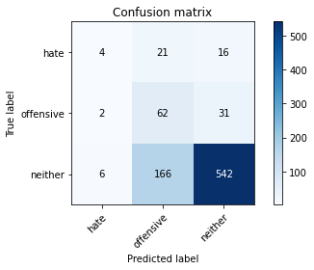

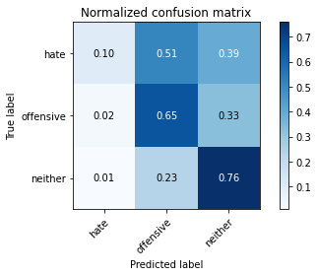

precision recall f1-score support

hate 0.33 0.10 0.15 41

offensive 0.25 0.65 0.36 95

neither 0.92 0.76 0.83 714

accuracy 0.72 850

macro avg 0.50 0.50 0.45 850

weighted avg 0.82 0.72 0.75 850

average eval_loss: 1.5607332122684077, accuracy: 0.7152941176470589

training 16 epoch...

10.528681755065918 seconds used......

16 training finished! average train loss: 0.042669726104045715

evaluating...

Confusion matrix, without normalization

[[ 1 4 36]

[ 0 8 87]

[ 2 21 691]]

Normalized confusion matrix

[[0.02439024 0.09756098 0.87804878]

[0. 0.08421053 0.91578947]

[0.00280112 0.02941176 0.96778711]]

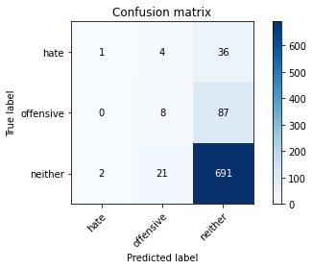

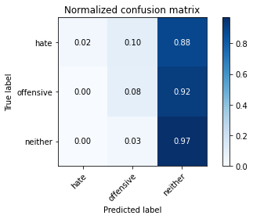

precision recall f1-score support

hate 0.33 0.02 0.05 41

offensive 0.24 0.08 0.12 95

neither 0.85 0.97 0.90 714

accuracy 0.82 850

macro avg 0.47 0.36 0.36 850

weighted avg 0.76 0.82 0.78 850

average eval_loss: 0.9668237927530859, accuracy: 0.8235294117647058

training 17 epoch...

10.59492015838623 seconds used......

17 training finished! average train loss: 0.027924669113081807

evaluating...

Confusion matrix, without normalization

[[ 5 17 19]

[ 5 45 45]

[ 26 133 555]]

Normalized confusion matrix

[[0.12195122 0.41463415 0.46341463]

[0.05263158 0.47368421 0.47368421]

[0.03641457 0.18627451 0.77731092]]

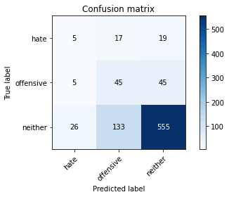

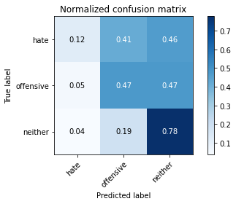

precision recall f1-score support

hate 0.14 0.12 0.13 41

offensive 0.23 0.47 0.31 95

neither 0.90 0.78 0.83 714

accuracy 0.71 850

macro avg 0.42 0.46 0.42 850

weighted avg 0.79 0.71 0.74 850

average eval_loss: 1.1837802590629043, accuracy: 0.711764705882353

training 18 epoch...

10.528404474258423 seconds used......

18 training finished! average train loss: 0.006442064110440417

evaluating...

Confusion matrix, without normalization

[[ 4 15 22]

[ 5 37 53]

[ 16 106 592]]

Normalized confusion matrix

[[0.09756098 0.36585366 0.53658537]

[0.05263158 0.38947368 0.55789474]

[0.02240896 0.14845938 0.82913165]]

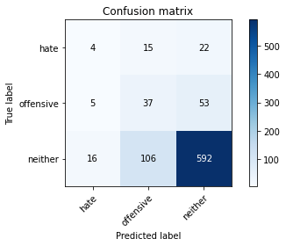

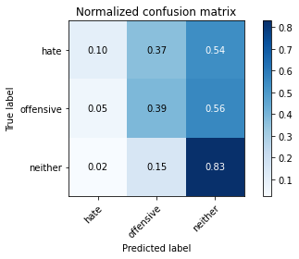

precision recall f1-score support

hate 0.16 0.10 0.12 41

offensive 0.23 0.39 0.29 95

neither 0.89 0.83 0.86 714

accuracy 0.74 850

macro avg 0.43 0.44 0.42 850

weighted avg 0.78 0.74 0.76 850

average eval_loss: 1.0929642267502184, accuracy: 0.7447058823529412

training 19 epoch...

10.518596887588501 seconds used......

19 training finished! average train loss: 0.002584727254893201

evaluating...

Confusion matrix, without normalization

[[ 3 15 23]

[ 4 32 59]

[ 12 87 615]]

Normalized confusion matrix

[[0.07317073 0.36585366 0.56097561]

[0.04210526 0.33684211 0.62105263]

[0.01680672 0.12184874 0.86134454]]

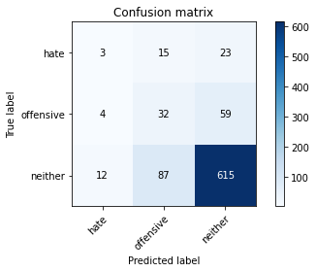

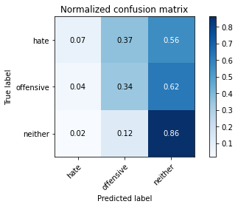

precision recall f1-score support

hate 0.16 0.07 0.10 41

offensive 0.24 0.34 0.28 95

neither 0.88 0.86 0.87 714

accuracy 0.76 850

macro avg 0.43 0.42 0.42 850

weighted avg 0.78 0.76 0.77 850

average eval_loss: 1.0865373345139995, accuracy: 0.7647058823529411

training 20 epoch...

10.516661643981934 seconds used......

20 training finished! average train loss: 0.0010913682573188382

evaluating...

Confusion matrix, without normalization

[[ 3 14 24]

[ 5 43 47]

[ 12 80 622]]

Normalized confusion matrix

[[0.07317073 0.34146341 0.58536585]

[0.05263158 0.45263158 0.49473684]

[0.01680672 0.11204482 0.87114846]]

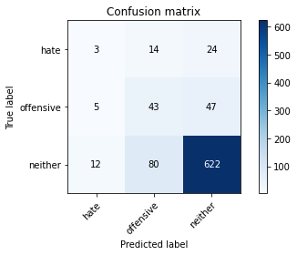

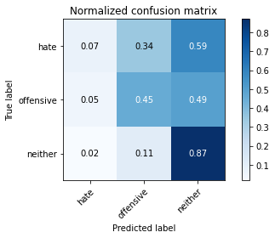

precision recall f1-score support

hate 0.15 0.07 0.10 41

offensive 0.31 0.45 0.37 95

neither 0.90 0.87 0.88 714

accuracy 0.79 850

macro avg 0.45 0.47 0.45 850

weighted avg 0.80 0.79 0.79 850

average eval_loss: 1.0475417388488706, accuracy: 0.7858823529411765

2 run......

training 1 epoch...

10.532417058944702 seconds used......

1 training finished! average train loss: 0.6657253815577581

evaluating...

Confusion matrix, without normalization

[[ 0 0 41]

[ 0 0 95]

[ 0 0 714]]

Normalized confusion matrix

[[0. 0. 1.]

[0. 0. 1.]

[0. 0. 1.]]





/opt/conda/lib/python3.7/site-packages/sklearn/metrics/_classification.py:1245: UndefinedMetricWarning: Precision and F-score are ill-defined and being set to 0.0 in labels with no predicted samples. Use `zero_division` parameter to control this behavior.

_warn_prf(average, modifier, msg_start, len(result))

/opt/conda/lib/python3.7/site-packages/sklearn/metrics/_classification.py:1245: UndefinedMetricWarning: Precision and F-score are ill-defined and being set to 0.0 in labels with no predicted samples. Use `zero_division` parameter to control this behavior.

_warn_prf(average, modifier, msg_start, len(result))

/opt/conda/lib/python3.7/site-packages/sklearn/metrics/_classification.py:1245: UndefinedMetricWarning: Precision and F-score are ill-defined and being set to 0.0 in labels with no predicted samples. Use `zero_division` parameter to control this behavior.

_warn_prf(average, modifier, msg_start, len(result))

precision recall f1-score support

hate 0.00 0.00 0.00 41

offensive 0.00 0.00 0.00 95

neither 0.84 1.00 0.91 714

accuracy 0.84 850

macro avg 0.28 0.33 0.30 850

weighted avg 0.71 0.84 0.77 850

average eval_loss: 0.5479675070490948, accuracy: 0.84

training 2 epoch...

10.562839984893799 seconds used......

2 training finished! average train loss: 0.5807850933991946

evaluating...

Confusion matrix, without normalization

[[ 13 0 28]

[ 8 0 87]

[ 25 0 689]]

Normalized confusion matrix

[[0.31707317 0. 0.68292683]

[0.08421053 0. 0.91578947]

[0.03501401 0. 0.96498599]]

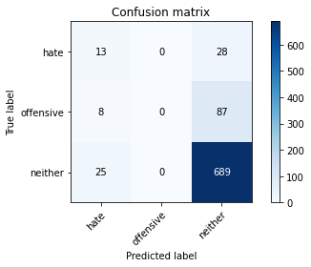

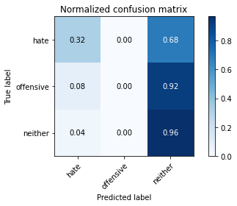

/opt/conda/lib/python3.7/site-packages/sklearn/metrics/_classification.py:1245: UndefinedMetricWarning: Precision and F-score are ill-defined and being set to 0.0 in labels with no predicted samples. Use `zero_division` parameter to control this behavior.

_warn_prf(average, modifier, msg_start, len(result))

/opt/conda/lib/python3.7/site-packages/sklearn/metrics/_classification.py:1245: UndefinedMetricWarning: Precision and F-score are ill-defined and being set to 0.0 in labels with no predicted samples. Use `zero_division` parameter to control this behavior.

_warn_prf(average, modifier, msg_start, len(result))

/opt/conda/lib/python3.7/site-packages/sklearn/metrics/_classification.py:1245: UndefinedMetricWarning: Precision and F-score are ill-defined and being set to 0.0 in labels with no predicted samples. Use `zero_division` parameter to control this behavior.

_warn_prf(average, modifier, msg_start, len(result))

precision recall f1-score support

hate 0.28 0.32 0.30 41

offensive 0.00 0.00 0.00 95

neither 0.86 0.96 0.91 714

accuracy 0.83 850

macro avg 0.38 0.43 0.40 850

weighted avg 0.73 0.83 0.78 850

average eval_loss: 0.4860796191144821, accuracy: 0.8258823529411765

training 3 epoch...

10.557690143585205 seconds used......

3 training finished! average train loss: 0.42406097742227405

evaluating...

Confusion matrix, without normalization

[[ 14 0 27]

[ 12 0 83]

[ 37 1 676]]

Normalized confusion matrix

[[0.34146341 0. 0.65853659]

[0.12631579 0. 0.87368421]

[0.05182073 0.00140056 0.94677871]]

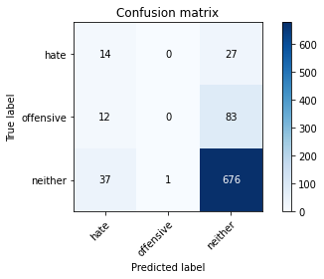

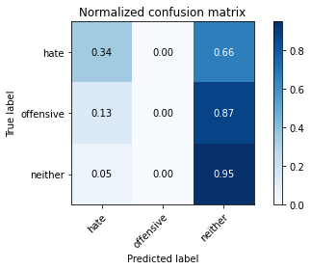

precision recall f1-score support

hate 0.22 0.34 0.27 41

offensive 0.00 0.00 0.00 95

neither 0.86 0.95 0.90 714

accuracy 0.81 850

macro avg 0.36 0.43 0.39 850

weighted avg 0.73 0.81 0.77 850

average eval_loss: 0.4649920600877945, accuracy: 0.8117647058823529

training 4 epoch...

10.579844951629639 seconds used......

4 training finished! average train loss: 0.2610499129845546

evaluating...

Confusion matrix, without normalization

[[ 8 0 33]

[ 7 2 86]

[ 19 6 689]]

Normalized confusion matrix

[[0.19512195 0. 0.80487805]

[0.07368421 0.02105263 0.90526316]

[0.02661064 0.00840336 0.96498599]]

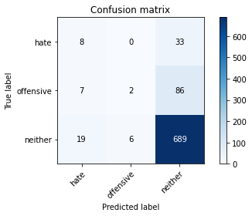

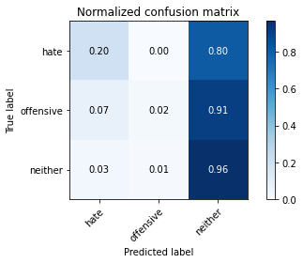

precision recall f1-score support

hate 0.24 0.20 0.21 41

offensive 0.25 0.02 0.04 95

neither 0.85 0.96 0.91 714

accuracy 0.82 850

macro avg 0.45 0.39 0.39 850

weighted avg 0.76 0.82 0.78 850

average eval_loss: 0.4747295058440677, accuracy: 0.8223529411764706

training 5 epoch...

10.568218469619751 seconds used......

5 training finished! average train loss: 0.13611861759653457

evaluating...

Confusion matrix, without normalization

[[ 7 6 28]

[ 12 25 58]

[ 27 50 637]]

Normalized confusion matrix

[[0.17073171 0.14634146 0.68292683]

[0.12631579 0.26315789 0.61052632]

[0.03781513 0.07002801 0.89215686]]

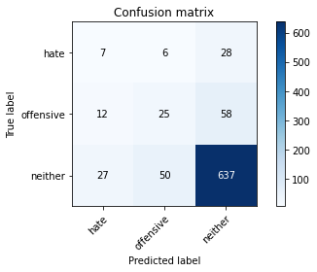

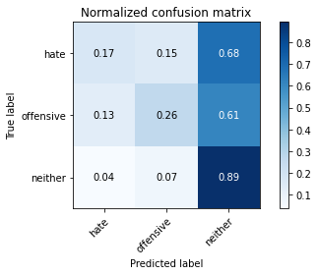

precision recall f1-score support

hate 0.15 0.17 0.16 41

offensive 0.31 0.26 0.28 95

neither 0.88 0.89 0.89 714

accuracy 0.79 850

macro avg 0.45 0.44 0.44 850

weighted avg 0.78 0.79 0.78 850

average eval_loss: 0.6110938633088195, accuracy: 0.7870588235294118

training 6 epoch...

10.61319875717163 seconds used......

6 training finished! average train loss: 0.06779047081676813

evaluating...

Confusion matrix, without normalization

[[ 8 3 30]

[ 10 16 69]

[ 28 43 643]]

Normalized confusion matrix

[[0.19512195 0.07317073 0.73170732]

[0.10526316 0.16842105 0.72631579]

[0.03921569 0.06022409 0.90056022]]

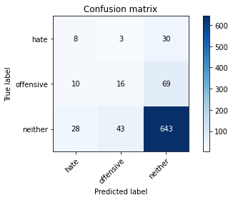

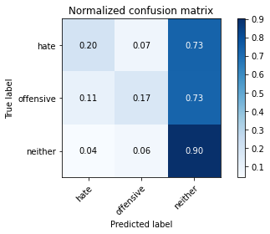

precision recall f1-score support

hate 0.17 0.20 0.18 41

offensive 0.26 0.17 0.20 95

neither 0.87 0.90 0.88 714

accuracy 0.78 850

macro avg 0.43 0.42 0.42 850

weighted avg 0.77 0.78 0.77 850

average eval_loss: 0.7209428215621386, accuracy: 0.7847058823529411

training 7 epoch...

10.58651065826416 seconds used......

7 training finished! average train loss: 0.03359384781036239

evaluating...

Confusion matrix, without normalization

[[ 8 3 30]

[ 5 18 72]

[ 21 49 644]]

Normalized confusion matrix

[[0.19512195 0.07317073 0.73170732]

[0.05263158 0.18947368 0.75789474]

[0.02941176 0.06862745 0.90196078]]

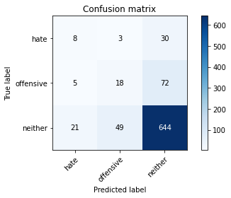

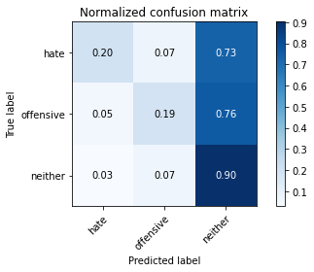

precision recall f1-score support

hate 0.24 0.20 0.21 41

offensive 0.26 0.19 0.22 95

neither 0.86 0.90 0.88 714

accuracy 0.79 850

macro avg 0.45 0.43 0.44 850

weighted avg 0.77 0.79 0.78 850

average eval_loss: 0.8375346859894033, accuracy: 0.788235294117647

training 8 epoch...

10.614811658859253 seconds used......

8 training finished! average train loss: 0.016196402656630828

evaluating...

Confusion matrix, without normalization

[[ 6 11 24]

[ 6 38 51]

[ 15 95 604]]

Normalized confusion matrix

[[0.14634146 0.26829268 0.58536585]

[0.06315789 0.4 0.53684211]

[0.0210084 0.13305322 0.84593838]]

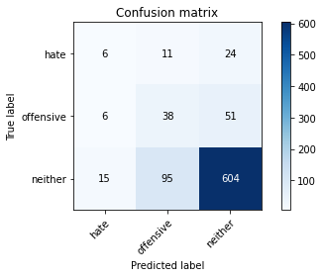

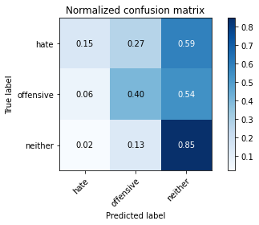

precision recall f1-score support

hate 0.22 0.15 0.18 41

offensive 0.26 0.40 0.32 95

neither 0.89 0.85 0.87 714

accuracy 0.76 850

macro avg 0.46 0.46 0.45 850

weighted avg 0.79 0.76 0.77 850

average eval_loss: 0.9863896379490967, accuracy: 0.7623529411764706

training 9 epoch...

10.556460618972778 seconds used......

9 training finished! average train loss: 0.011313692229585006

evaluating...

Confusion matrix, without normalization

[[ 6 21 14]

[ 5 45 45]

[ 15 170 529]]

Normalized confusion matrix

[[0.14634146 0.51219512 0.34146341]

[0.05263158 0.47368421 0.47368421]

[0.0210084 0.23809524 0.74089636]]

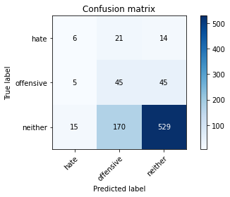

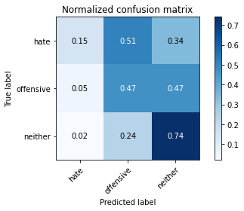

precision recall f1-score support

hate 0.23 0.15 0.18 41

offensive 0.19 0.47 0.27 95

neither 0.90 0.74 0.81 714

accuracy 0.68 850

macro avg 0.44 0.45 0.42 850

weighted avg 0.79 0.68 0.72 850

average eval_loss: 1.4361641140015753, accuracy: 0.6823529411764706

training 10 epoch...

10.566678524017334 seconds used......

10 training finished! average train loss: 0.009285172148464391

evaluating...

Confusion matrix, without normalization

[[ 7 17 17]

[ 5 35 55]

[ 16 133 565]]

Normalized confusion matrix

[[0.17073171 0.41463415 0.41463415]

[0.05263158 0.36842105 0.57894737]

[0.02240896 0.18627451 0.79131653]]

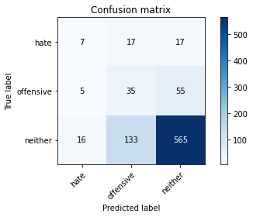

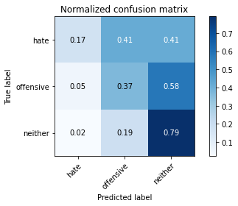

precision recall f1-score support

hate 0.25 0.17 0.20 41

offensive 0.19 0.37 0.25 95

neither 0.89 0.79 0.84 714

accuracy 0.71 850

macro avg 0.44 0.44 0.43 850

weighted avg 0.78 0.71 0.74 850

average eval_loss: 1.29436398647065, accuracy: 0.7141176470588235

training 11 epoch...

10.54332423210144 seconds used......

11 training finished! average train loss: 0.00801499327734256

evaluating...

Confusion matrix, without normalization

[[ 1 18 22]

[ 2 32 61]

[ 6 109 599]]

Normalized confusion matrix

[[0.02439024 0.43902439 0.53658537]

[0.02105263 0.33684211 0.64210526]

[0.00840336 0.15266106 0.83893557]]

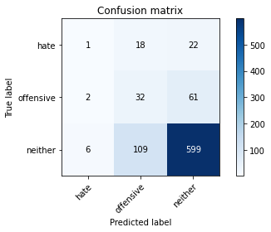

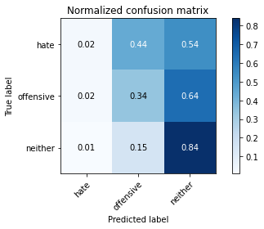

precision recall f1-score support

hate 0.11 0.02 0.04 41

offensive 0.20 0.34 0.25 95

neither 0.88 0.84 0.86 714

accuracy 0.74 850

macro avg 0.40 0.40 0.38 850

weighted avg 0.77 0.74 0.75 850

average eval_loss: 1.2720047814421611, accuracy: 0.7435294117647059

training 12 epoch...

10.568060398101807 seconds used......

12 training finished! average train loss: 0.005618613181062616

evaluating...

Confusion matrix, without normalization

[[ 7 4 30]

[ 5 21 69]

[ 11 66 637]]

Normalized confusion matrix

[[0.17073171 0.09756098 0.73170732]

[0.05263158 0.22105263 0.72631579]

[0.01540616 0.09243697 0.89215686]]

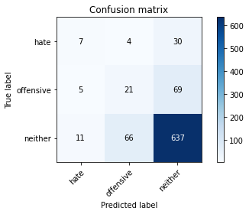

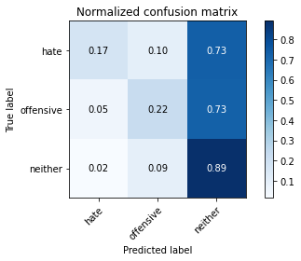

precision recall f1-score support

hate 0.30 0.17 0.22 41

offensive 0.23 0.22 0.23 95

neither 0.87 0.89 0.88 714

accuracy 0.78 850

macro avg 0.47 0.43 0.44 850

weighted avg 0.77 0.78 0.77 850

average eval_loss: 1.0680088848589655, accuracy: 0.7823529411764706

training 13 epoch...

10.664711475372314 seconds used......

13 training finished! average train loss: 0.0021042761397368917

evaluating...

Confusion matrix, without normalization

[[ 5 7 29]

[ 2 26 67]

[ 7 83 624]]

Normalized confusion matrix

[[0.12195122 0.17073171 0.70731707]

[0.02105263 0.27368421 0.70526316]

[0.00980392 0.1162465 0.87394958]]

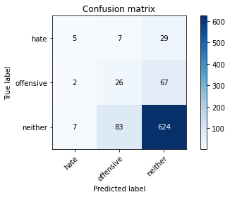

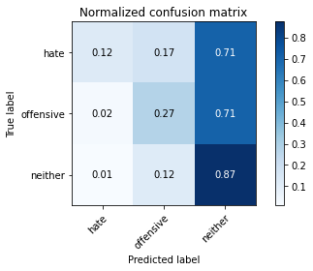

precision recall f1-score support

hate 0.36 0.12 0.18 41

offensive 0.22 0.27 0.25 95

neither 0.87 0.87 0.87 714

accuracy 0.77 850

macro avg 0.48 0.42 0.43 850

weighted avg 0.77 0.77 0.77 850

average eval_loss: 1.132455234678102, accuracy: 0.7705882352941177

training 14 epoch...

10.549172163009644 seconds used......

14 training finished! average train loss: 0.0013615393621596293

evaluating...

Confusion matrix, without normalization

[[ 6 4 31]

[ 2 22 71]

[ 11 60 643]]

Normalized confusion matrix

[[0.14634146 0.09756098 0.75609756]

[0.02105263 0.23157895 0.74736842]

[0.01540616 0.08403361 0.90056022]]

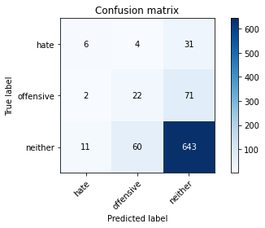

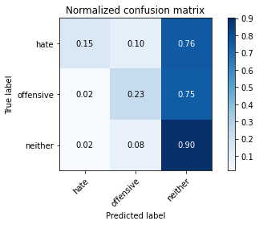

precision recall f1-score support

hate 0.32 0.15 0.20 41

offensive 0.26 0.23 0.24 95

neither 0.86 0.90 0.88 714

accuracy 0.79 850

macro avg 0.48 0.43 0.44 850

weighted avg 0.77 0.79 0.78 850

average eval_loss: 1.1282529553796468, accuracy: 0.7894117647058824

training 15 epoch...

10.61026406288147 seconds used......

15 training finished! average train loss: 0.0012266770963413785

evaluating...

Confusion matrix, without normalization

[[ 6 4 31]

[ 2 21 72]

[ 6 70 638]]

Normalized confusion matrix

[[0.14634146 0.09756098 0.75609756]

[0.02105263 0.22105263 0.75789474]

[0.00840336 0.09803922 0.89355742]]

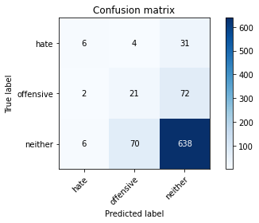

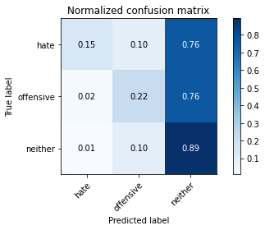

precision recall f1-score support

hate 0.43 0.15 0.22 41

offensive 0.22 0.22 0.22 95

neither 0.86 0.89 0.88 714

accuracy 0.78 850

macro avg 0.50 0.42 0.44 850

weighted avg 0.77 0.78 0.77 850

average eval_loss: 1.188739500461071, accuracy: 0.7823529411764706

training 16 epoch...

10.565663576126099 seconds used......

16 training finished! average train loss: 0.0010400740058125499

evaluating...

Confusion matrix, without normalization

[[ 6 8 27]

[ 3 28 64]

[ 11 92 611]]

Normalized confusion matrix

[[0.14634146 0.19512195 0.65853659]

[0.03157895 0.29473684 0.67368421]

[0.01540616 0.12885154 0.8557423 ]]

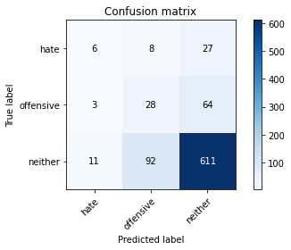

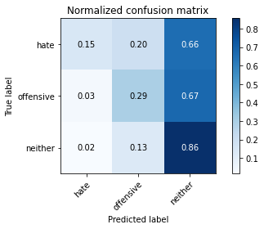

precision recall f1-score support

hate 0.30 0.15 0.20 41

offensive 0.22 0.29 0.25 95

neither 0.87 0.86 0.86 714

accuracy 0.76 850

macro avg 0.46 0.43 0.44 850

weighted avg 0.77 0.76 0.76 850

average eval_loss: 1.2865322593719357, accuracy: 0.7588235294117647

training 17 epoch...

10.560897827148438 seconds used......

17 training finished! average train loss: 0.0005844576988378182

evaluating...

Confusion matrix, without normalization

[[ 6 9 26]

[ 4 27 64]

[ 12 90 612]]

Normalized confusion matrix

[[0.14634146 0.2195122 0.63414634]

[0.04210526 0.28421053 0.67368421]

[0.01680672 0.12605042 0.85714286]]

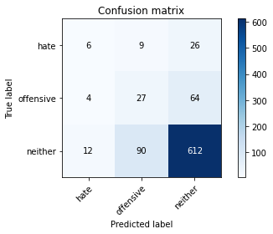

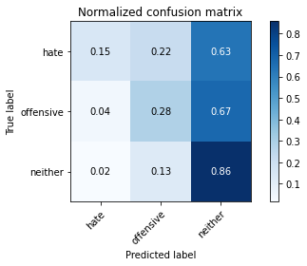

precision recall f1-score support

hate 0.27 0.15 0.19 41

offensive 0.21 0.28 0.24 95

neither 0.87 0.86 0.86 714

accuracy 0.76 850

macro avg 0.45 0.43 0.43 850

weighted avg 0.77 0.76 0.76 850

average eval_loss: 1.3007599127761984, accuracy: 0.7588235294117647

training 18 epoch...

10.562403202056885 seconds used......

18 training finished! average train loss: 0.0005081788692712927

evaluating...

Confusion matrix, without normalization

[[ 6 8 27]

[ 3 27 65]

[ 9 83 622]]

Normalized confusion matrix

[[0.14634146 0.19512195 0.65853659]

[0.03157895 0.28421053 0.68421053]

[0.01260504 0.1162465 0.87114846]]

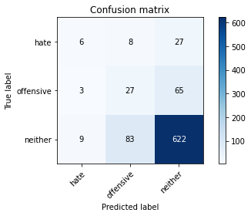

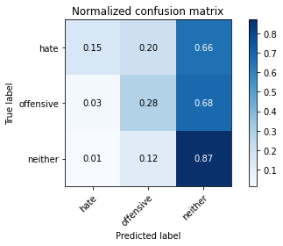

precision recall f1-score support

hate 0.33 0.15 0.20 41

offensive 0.23 0.28 0.25 95

neither 0.87 0.87 0.87 714

accuracy 0.77 850

macro avg 0.48 0.43 0.44 850

weighted avg 0.77 0.77 0.77 850

average eval_loss: 1.281446561019419, accuracy: 0.7705882352941177

training 19 epoch...

10.53090500831604 seconds used......

19 training finished! average train loss: 0.00042062123874739673

evaluating...

Confusion matrix, without normalization

[[ 6 9 26]

[ 3 31 61]

[ 8 102 604]]

Normalized confusion matrix

[[0.14634146 0.2195122 0.63414634]

[0.03157895 0.32631579 0.64210526]

[0.01120448 0.14285714 0.84593838]]

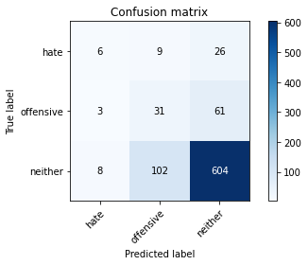

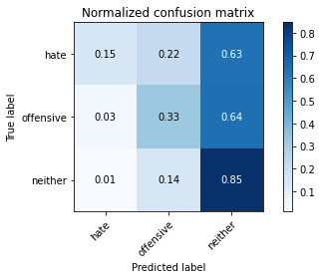

precision recall f1-score support

hate 0.35 0.15 0.21 41

offensive 0.22 0.33 0.26 95

neither 0.87 0.85 0.86 714

accuracy 0.75 850

macro avg 0.48 0.44 0.44 850

weighted avg 0.78 0.75 0.76 850

average eval_loss: 1.352346814216807, accuracy: 0.7541176470588236

training 20 epoch...

10.612400531768799 seconds used......

20 training finished! average train loss: 0.0005700920136475291

evaluating...

Confusion matrix, without normalization

[[ 2 13 26]

[ 2 32 61]

[ 6 108 600]]

Normalized confusion matrix

[[0.04878049 0.31707317 0.63414634]

[0.02105263 0.33684211 0.64210526]

[0.00840336 0.1512605 0.84033613]]

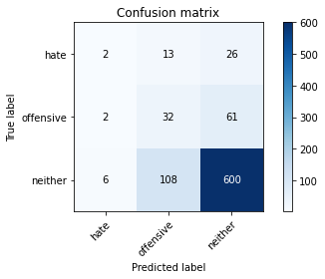

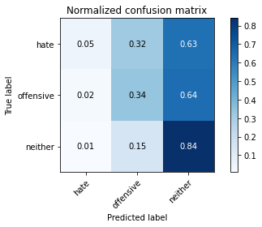

precision recall f1-score support

hate 0.20 0.05 0.08 41

offensive 0.21 0.34 0.26 95

neither 0.87 0.84 0.86 714

accuracy 0.75 850

macro avg 0.43 0.41 0.40 850

weighted avg 0.77 0.75 0.75 850

average eval_loss: 1.4254435120071087, accuracy: 0.7458823529411764

3 run......

training 1 epoch...

10.563734292984009 seconds used......

1 training finished! average train loss: 0.6802648901939392

evaluating...

Confusion matrix, without normalization

[[ 0 0 41]

[ 0 0 95]

[ 0 0 714]]

Normalized confusion matrix

[[0. 0. 1.]

[0. 0. 1.]

[0. 0. 1.]]





/opt/conda/lib/python3.7/site-packages/sklearn/metrics/_classification.py:1245: UndefinedMetricWarning: Precision and F-score are ill-defined and being set to 0.0 in labels with no predicted samples. Use `zero_division` parameter to control this behavior.

_warn_prf(average, modifier, msg_start, len(result))

/opt/conda/lib/python3.7/site-packages/sklearn/metrics/_classification.py:1245: UndefinedMetricWarning: Precision and F-score are ill-defined and being set to 0.0 in labels with no predicted samples. Use `zero_division` parameter to control this behavior.

_warn_prf(average, modifier, msg_start, len(result))

/opt/conda/lib/python3.7/site-packages/sklearn/metrics/_classification.py:1245: UndefinedMetricWarning: Precision and F-score are ill-defined and being set to 0.0 in labels with no predicted samples. Use `zero_division` parameter to control this behavior.

_warn_prf(average, modifier, msg_start, len(result))

precision recall f1-score support

hate 0.00 0.00 0.00 41

offensive 0.00 0.00 0.00 95

neither 0.84 1.00 0.91 714

accuracy 0.84 850

macro avg 0.28 0.33 0.30 850

weighted avg 0.71 0.84 0.77 850

average eval_loss: 0.49442081101411994, accuracy: 0.84

training 2 epoch...

10.643266677856445 seconds used......

2 training finished! average train loss: 0.5823884661381061

evaluating...

Confusion matrix, without normalization

[[ 15 0 26]

[ 22 0 73]

[ 87 0 627]]

Normalized confusion matrix

[[0.36585366 0. 0.63414634]

[0.23157895 0. 0.76842105]

[0.12184874 0. 0.87815126]]

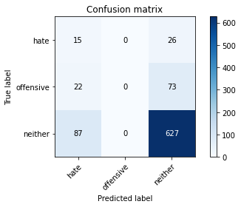

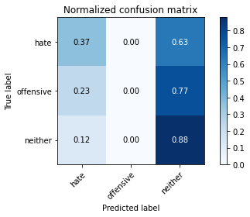

/opt/conda/lib/python3.7/site-packages/sklearn/metrics/_classification.py:1245: UndefinedMetricWarning: Precision and F-score are ill-defined and being set to 0.0 in labels with no predicted samples. Use `zero_division` parameter to control this behavior.

_warn_prf(average, modifier, msg_start, len(result))

/opt/conda/lib/python3.7/site-packages/sklearn/metrics/_classification.py:1245: UndefinedMetricWarning: Precision and F-score are ill-defined and being set to 0.0 in labels with no predicted samples. Use `zero_division` parameter to control this behavior.

_warn_prf(average, modifier, msg_start, len(result))

/opt/conda/lib/python3.7/site-packages/sklearn/metrics/_classification.py:1245: UndefinedMetricWarning: Precision and F-score are ill-defined and being set to 0.0 in labels with no predicted samples. Use `zero_division` parameter to control this behavior.

_warn_prf(average, modifier, msg_start, len(result))

precision recall f1-score support

hate 0.12 0.37 0.18 41

offensive 0.00 0.00 0.00 95

neither 0.86 0.88 0.87 714

accuracy 0.76 850

macro avg 0.33 0.41 0.35 850

weighted avg 0.73 0.76 0.74 850

average eval_loss: 0.5418907400480536, accuracy: 0.7552941176470588

training 3 epoch...

10.55412483215332 seconds used......

3 training finished! average train loss: 0.4481015333762536

evaluating...

Confusion matrix, without normalization

[[ 0 0 41]

[ 0 0 95]

[ 5 0 709]]

Normalized confusion matrix

[[0. 0. 1. ]

[0. 0. 1. ]

[0.0070028 0. 0.9929972]]

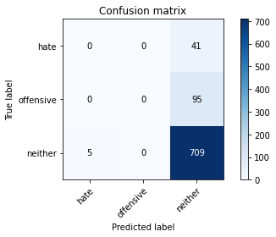

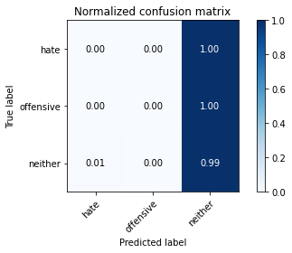

/opt/conda/lib/python3.7/site-packages/sklearn/metrics/_classification.py:1245: UndefinedMetricWarning: Precision and F-score are ill-defined and being set to 0.0 in labels with no predicted samples. Use `zero_division` parameter to control this behavior.

_warn_prf(average, modifier, msg_start, len(result))

/opt/conda/lib/python3.7/site-packages/sklearn/metrics/_classification.py:1245: UndefinedMetricWarning: Precision and F-score are ill-defined and being set to 0.0 in labels with no predicted samples. Use `zero_division` parameter to control this behavior.

_warn_prf(average, modifier, msg_start, len(result))

/opt/conda/lib/python3.7/site-packages/sklearn/metrics/_classification.py:1245: UndefinedMetricWarning: Precision and F-score are ill-defined and being set to 0.0 in labels with no predicted samples. Use `zero_division` parameter to control this behavior.

_warn_prf(average, modifier, msg_start, len(result))

precision recall f1-score support

hate 0.00 0.00 0.00 41

offensive 0.00 0.00 0.00 95

neither 0.84 0.99 0.91 714

accuracy 0.83 850

macro avg 0.28 0.33 0.30 850

weighted avg 0.70 0.83 0.76 850

average eval_loss: 0.42685138594445793, accuracy: 0.8341176470588235

training 4 epoch...

10.621148824691772 seconds used......

4 training finished! average train loss: 0.30036198393656655

evaluating...

Confusion matrix, without normalization

[[ 18 0 23]

[ 26 9 60]

[ 74 12 628]]

Normalized confusion matrix

[[0.43902439 0. 0.56097561]

[0.27368421 0.09473684 0.63157895]

[0.10364146 0.01680672 0.87955182]]

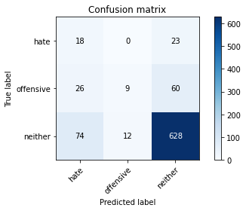

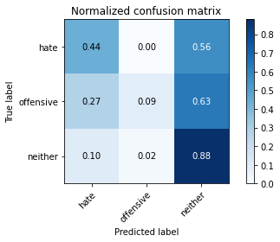

precision recall f1-score support

hate 0.15 0.44 0.23 41

offensive 0.43 0.09 0.16 95

neither 0.88 0.88 0.88 714

accuracy 0.77 850

macro avg 0.49 0.47 0.42 850

weighted avg 0.80 0.77 0.77 850

average eval_loss: 0.5322309113215915, accuracy: 0.7705882352941177

training 5 epoch...

10.590911149978638 seconds used......

5 training finished! average train loss: 0.17560927948126426

evaluating...

Confusion matrix, without normalization

[[ 5 4 32]

[ 5 9 81]

[ 16 19 679]]

Normalized confusion matrix

[[0.12195122 0.09756098 0.7804878 ]

[0.05263158 0.09473684 0.85263158]

[0.02240896 0.02661064 0.95098039]]

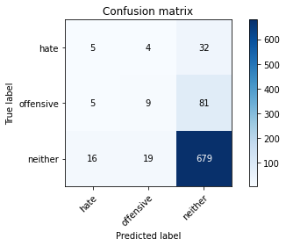

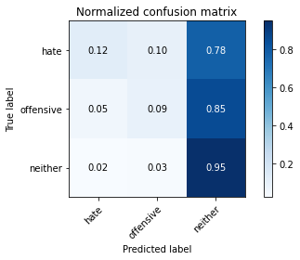

precision recall f1-score support

hate 0.19 0.12 0.15 41

offensive 0.28 0.09 0.14 95

neither 0.86 0.95 0.90 714

accuracy 0.82 850

macro avg 0.44 0.39 0.40 850

weighted avg 0.76 0.82 0.78 850

average eval_loss: 0.5390313429552195, accuracy: 0.8152941176470588

training 6 epoch...

10.556740760803223 seconds used......

6 training finished! average train loss: 0.0912433737459091

evaluating...

Confusion matrix, without normalization

[[ 5 8 28]

[ 6 28 61]

[ 19 51 644]]

Normalized confusion matrix

[[0.12195122 0.19512195 0.68292683]

[0.06315789 0.29473684 0.64210526]

[0.02661064 0.07142857 0.90196078]]

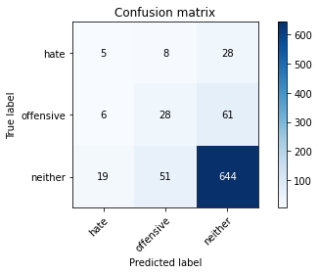

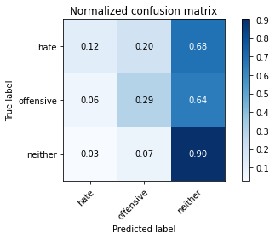

precision recall f1-score support

hate 0.17 0.12 0.14 41

offensive 0.32 0.29 0.31 95

neither 0.88 0.90 0.89 714

accuracy 0.80 850

macro avg 0.46 0.44 0.45 850

weighted avg 0.78 0.80 0.79 850

average eval_loss: 0.6509939906468918, accuracy: 0.7964705882352942

training 7 epoch...

10.571155071258545 seconds used......

7 training finished! average train loss: 0.05183007242874457

evaluating...

Confusion matrix, without normalization

[[ 7 11 23]

[ 12 33 50]

[ 30 78 606]]

Normalized confusion matrix

[[0.17073171 0.26829268 0.56097561]

[0.12631579 0.34736842 0.52631579]

[0.04201681 0.1092437 0.8487395 ]]

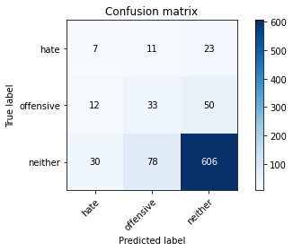

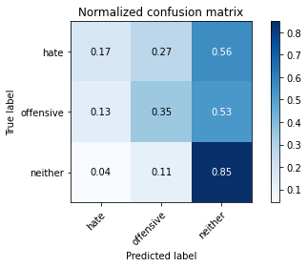

precision recall f1-score support

hate 0.14 0.17 0.16 41

offensive 0.27 0.35 0.30 95

neither 0.89 0.85 0.87 714

accuracy 0.76 850

macro avg 0.44 0.46 0.44 850

weighted avg 0.79 0.76 0.77 850

average eval_loss: 0.8288758898473366, accuracy: 0.76

training 8 epoch...

10.56723427772522 seconds used......

8 training finished! average train loss: 0.02202791295085962

evaluating...

Confusion matrix, without normalization

[[ 2 16 23]

[ 4 50 41]

[ 13 100 601]]

Normalized confusion matrix

[[0.04878049 0.3902439 0.56097561]

[0.04210526 0.52631579 0.43157895]

[0.01820728 0.14005602 0.84173669]]

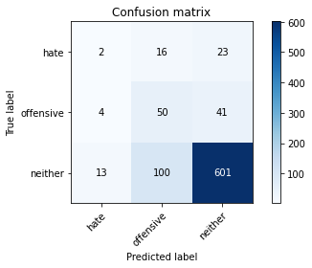

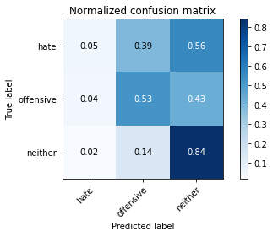

precision recall f1-score support

hate 0.11 0.05 0.07 41

offensive 0.30 0.53 0.38 95

neither 0.90 0.84 0.87 714

accuracy 0.77 850

macro avg 0.44 0.47 0.44 850

weighted avg 0.80 0.77 0.78 850

average eval_loss: 0.9279316133023564, accuracy: 0.768235294117647

training 9 epoch...

10.601515293121338 seconds used......

9 training finished! average train loss: 0.014138877861058483

evaluating...

Confusion matrix, without normalization

[[ 2 14 25]

[ 4 44 47]

[ 11 89 614]]

Normalized confusion matrix

[[0.04878049 0.34146341 0.6097561 ]

[0.04210526 0.46315789 0.49473684]

[0.01540616 0.12464986 0.85994398]]

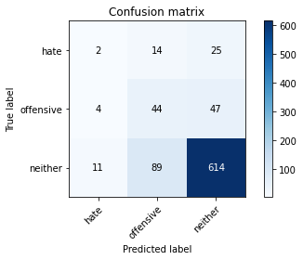

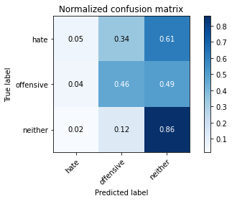

precision recall f1-score support

hate 0.12 0.05 0.07 41

offensive 0.30 0.46 0.36 95

neither 0.90 0.86 0.88 714

accuracy 0.78 850

macro avg 0.44 0.46 0.44 850

weighted avg 0.79 0.78 0.78 850

average eval_loss: 0.9259807987691602, accuracy: 0.7764705882352941

training 10 epoch...

10.55872130393982 seconds used......

10 training finished! average train loss: 0.01285597354782602

evaluating...

Confusion matrix, without normalization

[[ 5 18 18]

[ 5 47 43]

[ 19 97 598]]

Normalized confusion matrix

[[0.12195122 0.43902439 0.43902439]

[0.05263158 0.49473684 0.45263158]

[0.02661064 0.13585434 0.83753501]]

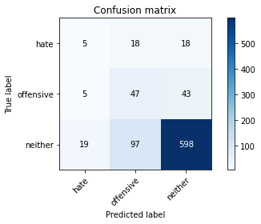

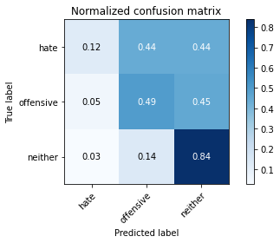

precision recall f1-score support

hate 0.17 0.12 0.14 41

offensive 0.29 0.49 0.37 95

neither 0.91 0.84 0.87 714

accuracy 0.76 850

macro avg 0.46 0.48 0.46 850

weighted avg 0.80 0.76 0.78 850

average eval_loss: 0.995028465384547, accuracy: 0.7647058823529411

training 11 epoch...

10.609007358551025 seconds used......

11 training finished! average train loss: 0.009562381689185993

evaluating...

Confusion matrix, without normalization

[[ 5 18 18]

[ 8 56 31]

[ 20 139 555]]

Normalized confusion matrix

[[0.12195122 0.43902439 0.43902439]

[0.08421053 0.58947368 0.32631579]

[0.0280112 0.19467787 0.77731092]]

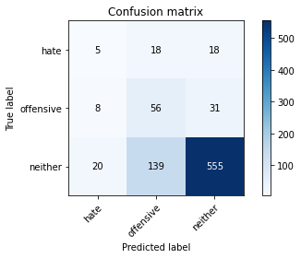

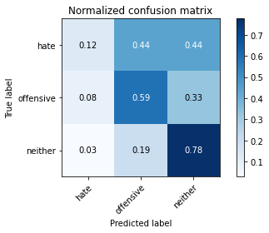

precision recall f1-score support

hate 0.15 0.12 0.14 41

offensive 0.26 0.59 0.36 95

neither 0.92 0.78 0.84 714

accuracy 0.72 850

macro avg 0.44 0.50 0.45 850

weighted avg 0.81 0.72 0.75 850

average eval_loss: 1.1710355614889332, accuracy: 0.7247058823529412

training 12 epoch...

10.561038732528687 seconds used......

12 training finished! average train loss: 0.004155193695064204

evaluating...

Confusion matrix, without normalization

[[ 2 19 20]

[ 4 50 41]

[ 10 117 587]]

Normalized confusion matrix

[[0.04878049 0.46341463 0.48780488]

[0.04210526 0.52631579 0.43157895]

[0.0140056 0.16386555 0.82212885]]

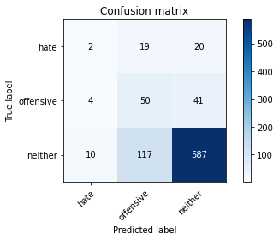

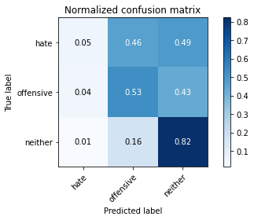

precision recall f1-score support

hate 0.12 0.05 0.07 41

offensive 0.27 0.53 0.36 95

neither 0.91 0.82 0.86 714

accuracy 0.75 850

macro avg 0.43 0.47 0.43 850

weighted avg 0.80 0.75 0.77 850

average eval_loss: 1.1594727982632913, accuracy: 0.7517647058823529

training 13 epoch...

10.548670768737793 seconds used......

13 training finished! average train loss: 0.0021076910735036316

evaluating...

Confusion matrix, without normalization

[[ 2 17 22]

[ 4 42 49]

[ 10 97 607]]

Normalized confusion matrix

[[0.04878049 0.41463415 0.53658537]

[0.04210526 0.44210526 0.51578947]

[0.0140056 0.13585434 0.85014006]]

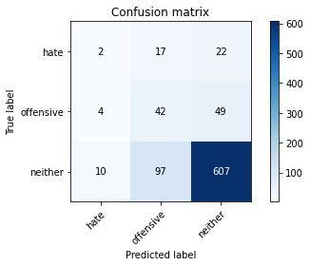

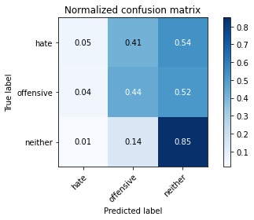

precision recall f1-score support

hate 0.12 0.05 0.07 41

offensive 0.27 0.44 0.33 95

neither 0.90 0.85 0.87 714

accuracy 0.77 850

macro avg 0.43 0.45 0.43 850

weighted avg 0.79 0.77 0.77 850

average eval_loss: 1.1144958267505836, accuracy: 0.7658823529411765

training 14 epoch...

10.571148157119751 seconds used......

14 training finished! average train loss: 0.0021360503267855023

evaluating...

Confusion matrix, without normalization

[[ 2 15 24]

[ 4 38 53]

[ 10 89 615]]

Normalized confusion matrix

[[0.04878049 0.36585366 0.58536585]

[0.04210526 0.4 0.55789474]

[0.0140056 0.12464986 0.86134454]]

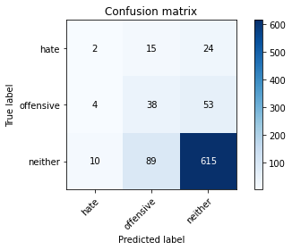

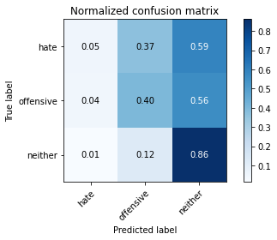

precision recall f1-score support

hate 0.12 0.05 0.07 41

offensive 0.27 0.40 0.32 95

neither 0.89 0.86 0.87 714

accuracy 0.77 850

macro avg 0.43 0.44 0.42 850

weighted avg 0.78 0.77 0.77 850

average eval_loss: 1.1006635051500864, accuracy: 0.7705882352941177

training 15 epoch...

10.570610284805298 seconds used......

15 training finished! average train loss: 0.0023939271753009124

evaluating...

Confusion matrix, without normalization

[[ 2 23 16]

[ 5 58 32]

[ 8 161 545]]

Normalized confusion matrix

[[0.04878049 0.56097561 0.3902439 ]

[0.05263158 0.61052632 0.33684211]

[0.01120448 0.2254902 0.76330532]]

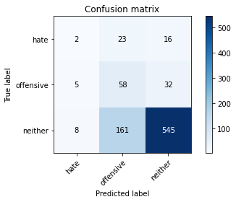

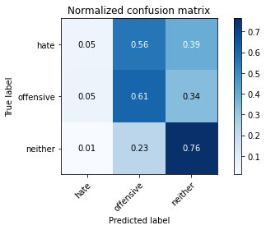

precision recall f1-score support

hate 0.13 0.05 0.07 41

offensive 0.24 0.61 0.34 95

neither 0.92 0.76 0.83 714

accuracy 0.71 850

macro avg 0.43 0.47 0.42 850

weighted avg 0.81 0.71 0.74 850

average eval_loss: 1.428121213552469, accuracy: 0.711764705882353

training 16 epoch...

10.67064356803894 seconds used......

16 training finished! average train loss: 0.0012822937556148436

evaluating...

Confusion matrix, without normalization

[[ 3 16 22]

[ 4 42 49]

[ 11 110 593]]

Normalized confusion matrix

[[0.07317073 0.3902439 0.53658537]

[0.04210526 0.44210526 0.51578947]

[0.01540616 0.15406162 0.83053221]]

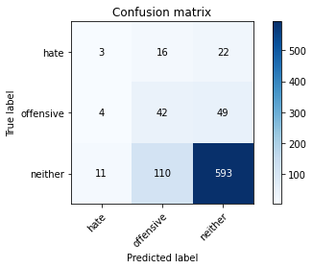

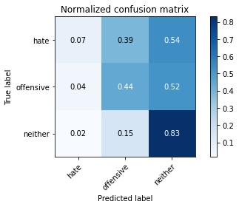

precision recall f1-score support

hate 0.17 0.07 0.10 41

offensive 0.25 0.44 0.32 95

neither 0.89 0.83 0.86 714

accuracy 0.75 850

macro avg 0.44 0.45 0.43 850

weighted avg 0.79 0.75 0.76 850

average eval_loss: 1.2406927435655488, accuracy: 0.7505882352941177

training 17 epoch...

10.562292337417603 seconds used......

17 training finished! average train loss: 0.0014236371731385588

evaluating...

Confusion matrix, without normalization

[[ 4 12 25]

[ 5 40 50]

[ 12 85 617]]

Normalized confusion matrix

[[0.09756098 0.29268293 0.6097561 ]

[0.05263158 0.42105263 0.52631579]

[0.01680672 0.11904762 0.86414566]]

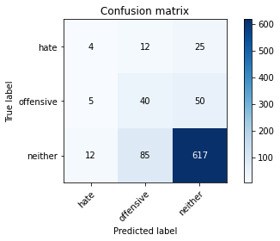

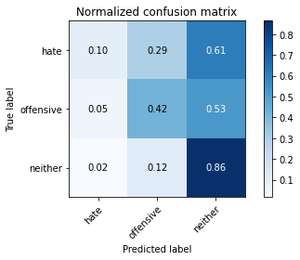

precision recall f1-score support

hate 0.19 0.10 0.13 41

offensive 0.29 0.42 0.34 95

neither 0.89 0.86 0.88 714

accuracy 0.78 850

macro avg 0.46 0.46 0.45 850

weighted avg 0.79 0.78 0.78 850

average eval_loss: 1.1918879746847588, accuracy: 0.7776470588235294

training 18 epoch...

10.619567394256592 seconds used......

18 training finished! average train loss: 0.0010114685562887015

evaluating...

Confusion matrix, without normalization

[[ 2 16 23]

[ 4 42 49]

[ 8 102 604]]

Normalized confusion matrix

[[0.04878049 0.3902439 0.56097561]

[0.04210526 0.44210526 0.51578947]

[0.01120448 0.14285714 0.84593838]]

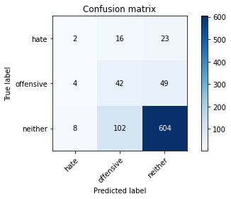

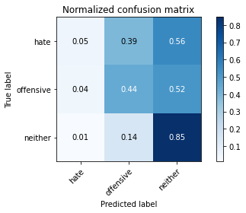

precision recall f1-score support

hate 0.14 0.05 0.07 41

offensive 0.26 0.44 0.33 95

neither 0.89 0.85 0.87 714

accuracy 0.76 850

macro avg 0.43 0.45 0.42 850

weighted avg 0.79 0.76 0.77 850

average eval_loss: 1.2771050410888694, accuracy: 0.7623529411764706

training 19 epoch...

10.5556161403656 seconds used......

19 training finished! average train loss: 0.007709268976199942

evaluating...

Confusion matrix, without normalization

[[ 7 20 14]

[ 10 60 25]

[ 31 164 519]]

Normalized confusion matrix

[[0.17073171 0.48780488 0.34146341]

[0.10526316 0.63157895 0.26315789]

[0.04341737 0.22969188 0.72689076]]

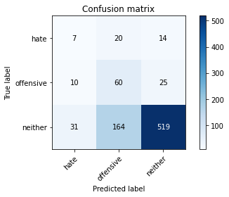

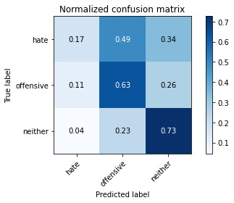

precision recall f1-score support

hate 0.15 0.17 0.16 41

offensive 0.25 0.63 0.35 95

neither 0.93 0.73 0.82 714

accuracy 0.69 850

macro avg 0.44 0.51 0.44 850

weighted avg 0.82 0.69 0.73 850

average eval_loss: 1.4928378153004858, accuracy: 0.6894117647058824

training 20 epoch...

10.578668355941772 seconds used......

20 training finished! average train loss: 0.010766034143923136

evaluating...

Confusion matrix, without normalization

[[ 3 15 23]

[ 6 53 36]

[ 14 88 612]]

Normalized confusion matrix

[[0.07317073 0.36585366 0.56097561]

[0.06315789 0.55789474 0.37894737]

[0.01960784 0.1232493 0.85714286]]

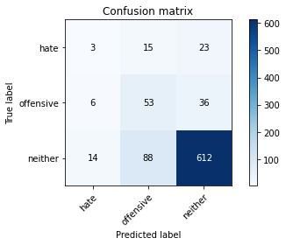

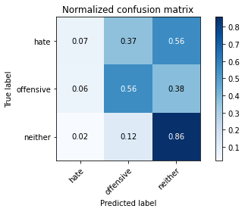

precision recall f1-score support

hate 0.13 0.07 0.09 41

offensive 0.34 0.56 0.42 95

neither 0.91 0.86 0.88 714

accuracy 0.79 850

macro avg 0.46 0.50 0.47 850

weighted avg 0.81 0.79 0.79 850

average eval_loss: 1.0363301980765374, accuracy: 0.7858823529411765

4 run......

training 1 epoch...

10.567618370056152 seconds used......

1 training finished! average train loss: 0.6944328399804922

evaluating...

Confusion matrix, without normalization

[[ 0 0 41]

[ 0 0 95]

[ 0 0 714]]

Normalized confusion matrix

[[0. 0. 1.]

[0. 0. 1.]

[0. 0. 1.]]





/opt/conda/lib/python3.7/site-packages/sklearn/metrics/_classification.py:1245: UndefinedMetricWarning: Precision and F-score are ill-defined and being set to 0.0 in labels with no predicted samples. Use `zero_division` parameter to control this behavior.

_warn_prf(average, modifier, msg_start, len(result))

/opt/conda/lib/python3.7/site-packages/sklearn/metrics/_classification.py:1245: UndefinedMetricWarning: Precision and F-score are ill-defined and being set to 0.0 in labels with no predicted samples. Use `zero_division` parameter to control this behavior.

_warn_prf(average, modifier, msg_start, len(result))

/opt/conda/lib/python3.7/site-packages/sklearn/metrics/_classification.py:1245: UndefinedMetricWarning: Precision and F-score are ill-defined and being set to 0.0 in labels with no predicted samples. Use `zero_division` parameter to control this behavior.

_warn_prf(average, modifier, msg_start, len(result))

precision recall f1-score support

hate 0.00 0.00 0.00 41

offensive 0.00 0.00 0.00 95

neither 0.84 1.00 0.91 714

accuracy 0.84 850

macro avg 0.28 0.33 0.30 850

weighted avg 0.71 0.84 0.77 850

average eval_loss: 0.47803955577140633, accuracy: 0.84

training 2 epoch...

10.559746265411377 seconds used......

2 training finished! average train loss: 0.5936521392602186

evaluating...

Confusion matrix, without normalization

[[ 0 0 41]

[ 0 0 95]

[ 0 0 714]]

Normalized confusion matrix

[[0. 0. 1.]

[0. 0. 1.]

[0. 0. 1.]]





/opt/conda/lib/python3.7/site-packages/sklearn/metrics/_classification.py:1245: UndefinedMetricWarning: Precision and F-score are ill-defined and being set to 0.0 in labels with no predicted samples. Use `zero_division` parameter to control this behavior.

_warn_prf(average, modifier, msg_start, len(result))

/opt/conda/lib/python3.7/site-packages/sklearn/metrics/_classification.py:1245: UndefinedMetricWarning: Precision and F-score are ill-defined and being set to 0.0 in labels with no predicted samples. Use `zero_division` parameter to control this behavior.

_warn_prf(average, modifier, msg_start, len(result))

/opt/conda/lib/python3.7/site-packages/sklearn/metrics/_classification.py:1245: UndefinedMetricWarning: Precision and F-score are ill-defined and being set to 0.0 in labels with no predicted samples. Use `zero_division` parameter to control this behavior.

_warn_prf(average, modifier, msg_start, len(result))

precision recall f1-score support

hate 0.00 0.00 0.00 41

offensive 0.00 0.00 0.00 95

neither 0.84 1.00 0.91 714

accuracy 0.84 850

macro avg 0.28 0.33 0.30 850

weighted avg 0.71 0.84 0.77 850

average eval_loss: 0.429038766251747, accuracy: 0.84

training 3 epoch...

10.546631336212158 seconds used......

3 training finished! average train loss: 0.45682428845992457

evaluating...

Confusion matrix, without normalization

[[ 5 0 36]

[ 5 0 90]

[ 22 0 692]]

Normalized confusion matrix

[[0.12195122 0. 0.87804878]

[0.05263158 0. 0.94736842]

[0.03081232 0. 0.96918768]]

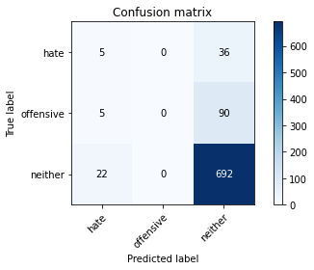

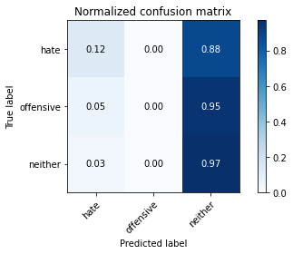

/opt/conda/lib/python3.7/site-packages/sklearn/metrics/_classification.py:1245: UndefinedMetricWarning: Precision and F-score are ill-defined and being set to 0.0 in labels with no predicted samples. Use `zero_division` parameter to control this behavior.

_warn_prf(average, modifier, msg_start, len(result))

/opt/conda/lib/python3.7/site-packages/sklearn/metrics/_classification.py:1245: UndefinedMetricWarning: Precision and F-score are ill-defined and being set to 0.0 in labels with no predicted samples. Use `zero_division` parameter to control this behavior.

_warn_prf(average, modifier, msg_start, len(result))

/opt/conda/lib/python3.7/site-packages/sklearn/metrics/_classification.py:1245: UndefinedMetricWarning: Precision and F-score are ill-defined and being set to 0.0 in labels with no predicted samples. Use `zero_division` parameter to control this behavior.

_warn_prf(average, modifier, msg_start, len(result))

precision recall f1-score support

hate 0.16 0.12 0.14 41

offensive 0.00 0.00 0.00 95

neither 0.85 0.97 0.90 714

accuracy 0.82 850

macro avg 0.33 0.36 0.35 850

weighted avg 0.72 0.82 0.77 850

average eval_loss: 0.4282556119439907, accuracy: 0.82

training 4 epoch...

10.53988790512085 seconds used......

4 training finished! average train loss: 0.2707720497479806

evaluating...

Confusion matrix, without normalization

[[ 17 0 24]

[ 24 35 36]

[ 91 31 592]]

Normalized confusion matrix

[[0.41463415 0. 0.58536585]

[0.25263158 0.36842105 0.37894737]

[0.12745098 0.04341737 0.82913165]]

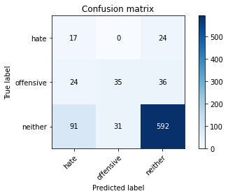

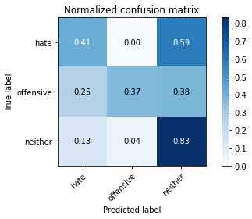

precision recall f1-score support

hate 0.13 0.41 0.20 41

offensive 0.53 0.37 0.43 95

neither 0.91 0.83 0.87 714

accuracy 0.76 850

macro avg 0.52 0.54 0.50 850

weighted avg 0.83 0.76 0.79 850

average eval_loss: 0.6295384570609691, accuracy: 0.7576470588235295

training 5 epoch...

10.61546802520752 seconds used......

5 training finished! average train loss: 0.16260130531512773

evaluating...

Confusion matrix, without normalization

[[ 5 6 30]

[ 6 17 72]

[ 22 27 665]]

Normalized confusion matrix

[[0.12195122 0.14634146 0.73170732]

[0.06315789 0.17894737 0.75789474]

[0.03081232 0.03781513 0.93137255]]

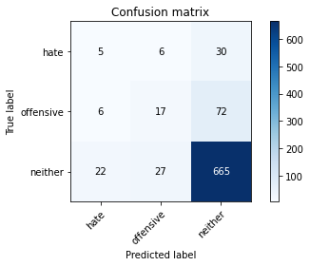

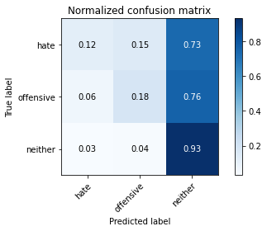

precision recall f1-score support

hate 0.15 0.12 0.14 41

offensive 0.34 0.18 0.23 95

neither 0.87 0.93 0.90 714

accuracy 0.81 850

macro avg 0.45 0.41 0.42 850

weighted avg 0.77 0.81 0.79 850

average eval_loss: 0.5606929636668674, accuracy: 0.808235294117647

training 6 epoch...

10.581539392471313 seconds used......

6 training finished! average train loss: 0.0842540929810359

evaluating...

Confusion matrix, without normalization

[[ 17 5 19]

[ 14 45 36]

[ 68 68 578]]

Normalized confusion matrix

[[0.41463415 0.12195122 0.46341463]

[0.14736842 0.47368421 0.37894737]

[0.0952381 0.0952381 0.80952381]]

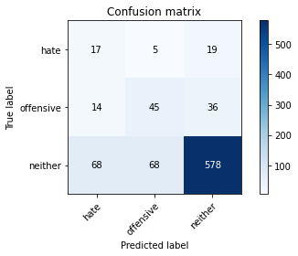

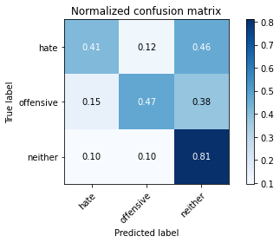

precision recall f1-score support

hate 0.17 0.41 0.24 41

offensive 0.38 0.47 0.42 95

neither 0.91 0.81 0.86 714

accuracy 0.75 850

macro avg 0.49 0.57 0.51 850

weighted avg 0.82 0.75 0.78 850

average eval_loss: 0.7711642924696207, accuracy: 0.7529411764705882

training 7 epoch...

10.595519304275513 seconds used......

7 training finished! average train loss: 0.06366867872958

evaluating...

Confusion matrix, without normalization

[[ 1 9 31]

[ 2 29 64]

[ 13 47 654]]

Normalized confusion matrix

[[0.02439024 0.2195122 0.75609756]

[0.02105263 0.30526316 0.67368421]

[0.01820728 0.06582633 0.91596639]]

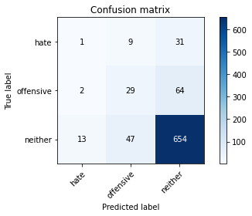

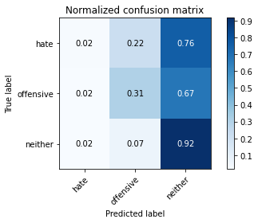

precision recall f1-score support

hate 0.06 0.02 0.04 41

offensive 0.34 0.31 0.32 95

neither 0.87 0.92 0.89 714

accuracy 0.80 850

macro avg 0.43 0.42 0.42 850

weighted avg 0.77 0.80 0.79 850

average eval_loss: 0.7479793327524825, accuracy: 0.8047058823529412

training 8 epoch...

10.55341124534607 seconds used......

8 training finished! average train loss: 0.028723562978064783

evaluating...

Confusion matrix, without normalization

[[ 1 13 27]

[ 1 24 70]

[ 5 78 631]]

Normalized confusion matrix

[[0.02439024 0.31707317 0.65853659]

[0.01052632 0.25263158 0.73684211]

[0.0070028 0.1092437 0.8837535 ]]

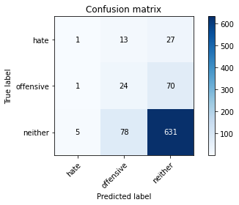

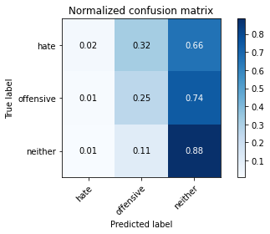

precision recall f1-score support

hate 0.14 0.02 0.04 41

offensive 0.21 0.25 0.23 95

neither 0.87 0.88 0.88 714

accuracy 0.77 850

macro avg 0.41 0.39 0.38 850

weighted avg 0.76 0.77 0.76 850

average eval_loss: 0.9424416432211306, accuracy: 0.7717647058823529

training 9 epoch...

10.627555847167969 seconds used......

9 training finished! average train loss: 0.01565887532913341

evaluating...

Confusion matrix, without normalization

[[ 2 15 24]

[ 2 52 41]

[ 18 103 593]]

Normalized confusion matrix

[[0.04878049 0.36585366 0.58536585]

[0.02105263 0.54736842 0.43157895]

[0.02521008 0.1442577 0.83053221]]

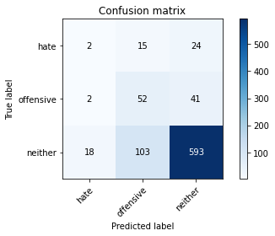

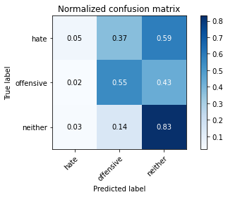

precision recall f1-score support

hate 0.09 0.05 0.06 41

offensive 0.31 0.55 0.39 95

neither 0.90 0.83 0.86 714

accuracy 0.76 850

macro avg 0.43 0.48 0.44 850

weighted avg 0.80 0.76 0.77 850

average eval_loss: 0.9662884646311922, accuracy: 0.7611764705882353

training 10 epoch...

10.588781595230103 seconds used......

10 training finished! average train loss: 0.006965610282853819

evaluating...

Confusion matrix, without normalization

[[ 3 17 21]

[ 4 59 32]

[ 23 109 582]]

Normalized confusion matrix

[[0.07317073 0.41463415 0.51219512]

[0.04210526 0.62105263 0.33684211]

[0.03221289 0.15266106 0.81512605]]

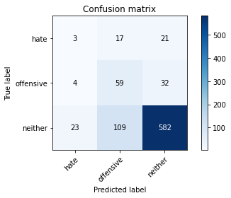

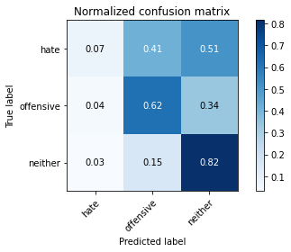

precision recall f1-score support

hate 0.10 0.07 0.08 41

offensive 0.32 0.62 0.42 95

neither 0.92 0.82 0.86 714

accuracy 0.76 850

macro avg 0.45 0.50 0.46 850

weighted avg 0.81 0.76 0.78 850

average eval_loss: 1.0459961299459601, accuracy: 0.7576470588235295

training 11 epoch...

10.542858362197876 seconds used......

11 training finished! average train loss: 0.0058575981117498415

evaluating...

Confusion matrix, without normalization

[[ 2 13 26]

[ 1 45 49]

[ 12 90 612]]

Normalized confusion matrix

[[0.04878049 0.31707317 0.63414634]

[0.01052632 0.47368421 0.51578947]

[0.01680672 0.12605042 0.85714286]]

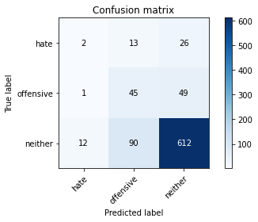

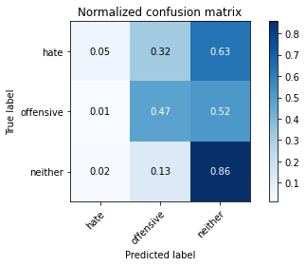

precision recall f1-score support

hate 0.13 0.05 0.07 41

offensive 0.30 0.47 0.37 95

neither 0.89 0.86 0.87 714

accuracy 0.78 850

macro avg 0.44 0.46 0.44 850

weighted avg 0.79 0.78 0.78 850

average eval_loss: 1.0260780793804198, accuracy: 0.7752941176470588

training 12 epoch...

10.565979719161987 seconds used......

12 training finished! average train loss: 0.003909612947161524

evaluating...

Confusion matrix, without normalization

[[ 1 16 24]

[ 2 44 49]

[ 11 95 608]]

Normalized confusion matrix

[[0.02439024 0.3902439 0.58536585]

[0.02105263 0.46315789 0.51578947]

[0.01540616 0.13305322 0.85154062]]

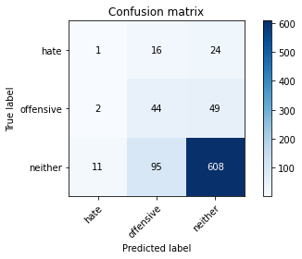

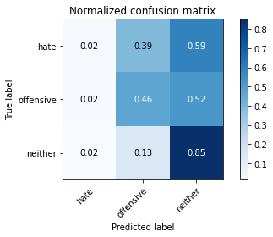

precision recall f1-score support

hate 0.07 0.02 0.04 41

offensive 0.28 0.46 0.35 95

neither 0.89 0.85 0.87 714

accuracy 0.77 850

macro avg 0.42 0.45 0.42 850

weighted avg 0.79 0.77 0.77 850

average eval_loss: 1.0786007509071402, accuracy: 0.768235294117647

training 13 epoch...

10.547427415847778 seconds used......

13 training finished! average train loss: 0.0017101972954920851

evaluating...

Confusion matrix, without normalization

[[ 1 12 28]

[ 1 40 54]

[ 5 88 621]]

Normalized confusion matrix

[[0.02439024 0.29268293 0.68292683]

[0.01052632 0.42105263 0.56842105]

[0.0070028 0.1232493 0.8697479 ]]

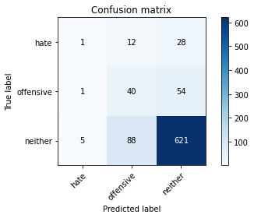

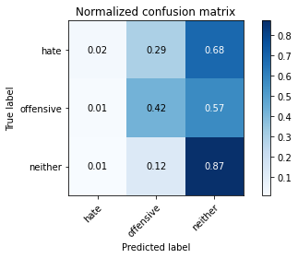

precision recall f1-score support

hate 0.14 0.02 0.04 41

offensive 0.29 0.42 0.34 95

neither 0.88 0.87 0.88 714

accuracy 0.78 850

macro avg 0.44 0.44 0.42 850

weighted avg 0.78 0.78 0.78 850

average eval_loss: 1.1000128799635203, accuracy: 0.7788235294117647

training 14 epoch...

10.583726167678833 seconds used......

14 training finished! average train loss: 0.0021177947492105886

evaluating...

Confusion matrix, without normalization

[[ 2 19 20]

[ 2 59 34]

[ 14 122 578]]

Normalized confusion matrix

[[0.04878049 0.46341463 0.48780488]

[0.02105263 0.62105263 0.35789474]

[0.01960784 0.17086835 0.80952381]]

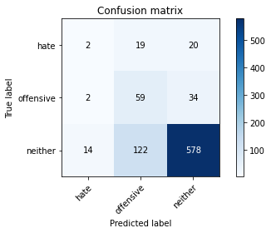

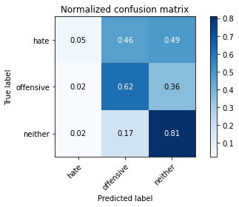

precision recall f1-score support

hate 0.11 0.05 0.07 41

offensive 0.29 0.62 0.40 95

neither 0.91 0.81 0.86 714

accuracy 0.75 850

macro avg 0.44 0.49 0.44 850

weighted avg 0.81 0.75 0.77 850

average eval_loss: 1.2220936347757532, accuracy: 0.7517647058823529

training 15 epoch...

10.544931173324585 seconds used......

15 training finished! average train loss: 0.001727439794026745

evaluating...

Confusion matrix, without normalization

[[ 1 16 24]

[ 1 48 46]

[ 8 106 600]]

Normalized confusion matrix

[[0.02439024 0.3902439 0.58536585]

[0.01052632 0.50526316 0.48421053]

[0.01120448 0.14845938 0.84033613]]

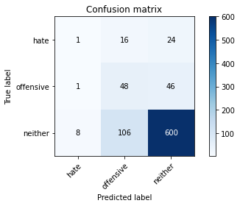

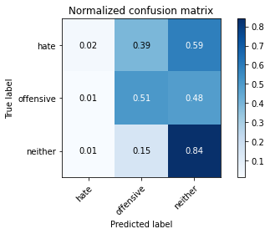

precision recall f1-score support

hate 0.10 0.02 0.04 41

offensive 0.28 0.51 0.36 95

neither 0.90 0.84 0.87 714

accuracy 0.76 850

macro avg 0.43 0.46 0.42 850

weighted avg 0.79 0.76 0.77 850

average eval_loss: 1.175331780754658, accuracy: 0.7635294117647059

training 16 epoch...

10.618009805679321 seconds used......

16 training finished! average train loss: 0.001316462552998788

evaluating...

Confusion matrix, without normalization

[[ 2 15 24]

[ 1 46 48]

[ 14 97 603]]

Normalized confusion matrix

[[0.04878049 0.36585366 0.58536585]

[0.01052632 0.48421053 0.50526316]

[0.01960784 0.13585434 0.84453782]]

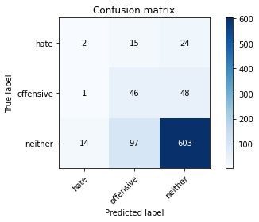

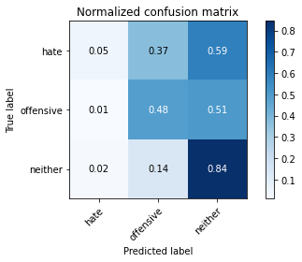

precision recall f1-score support

hate 0.12 0.05 0.07 41

offensive 0.29 0.48 0.36 95

neither 0.89 0.84 0.87 714

accuracy 0.77 850

macro avg 0.43 0.46 0.43 850

weighted avg 0.79 0.77 0.77 850

average eval_loss: 1.1676192232319642, accuracy: 0.7658823529411765

training 17 epoch...

10.575034141540527 seconds used......

17 training finished! average train loss: 0.002426470610169837

evaluating...

Confusion matrix, without normalization

[[ 1 21 19]

[ 1 59 35]

[ 11 145 558]]

Normalized confusion matrix

[[0.02439024 0.51219512 0.46341463]

[0.01052632 0.62105263 0.36842105]

[0.01540616 0.20308123 0.78151261]]

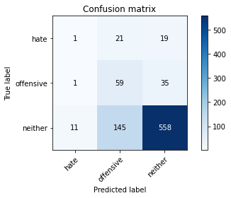

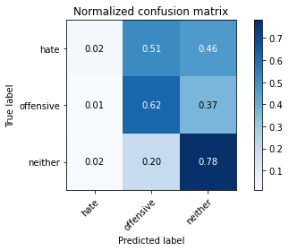

precision recall f1-score support

hate 0.08 0.02 0.04 41

offensive 0.26 0.62 0.37 95

neither 0.91 0.78 0.84 714

accuracy 0.73 850

macro avg 0.42 0.48 0.42 850

weighted avg 0.80 0.73 0.75 850

average eval_loss: 1.4170141119217543, accuracy: 0.7270588235294118

training 18 epoch...

10.56429672241211 seconds used......

18 training finished! average train loss: 0.0034123918393071597

evaluating...

Confusion matrix, without normalization

[[ 1 15 25]

[ 1 46 48]

[ 9 108 597]]

Normalized confusion matrix

[[0.02439024 0.36585366 0.6097561 ]

[0.01052632 0.48421053 0.50526316]

[0.01260504 0.1512605 0.83613445]]

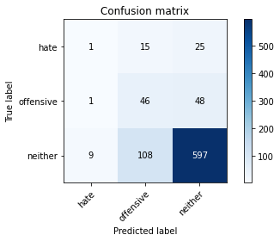

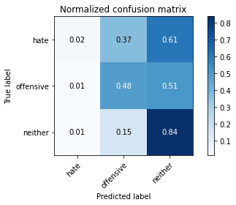

precision recall f1-score support

hate 0.09 0.02 0.04 41

offensive 0.27 0.48 0.35 95

neither 0.89 0.84 0.86 714

accuracy 0.76 850

macro avg 0.42 0.45 0.42 850

weighted avg 0.78 0.76 0.77 850

average eval_loss: 1.235013488360659, accuracy: 0.7576470588235295

training 19 epoch...

10.562957525253296 seconds used......

19 training finished! average train loss: 0.001565168837371927

evaluating...

Confusion matrix, without normalization

[[ 1 14 26]

[ 1 50 44]

[ 8 108 598]]

Normalized confusion matrix

[[0.02439024 0.34146341 0.63414634]

[0.01052632 0.52631579 0.46315789]

[0.01120448 0.1512605 0.83753501]]

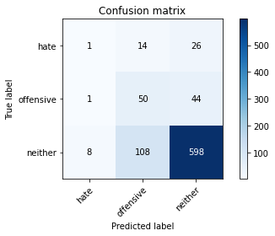

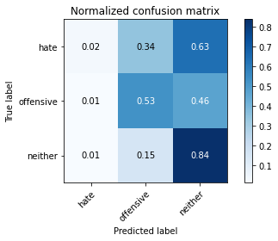

precision recall f1-score support

hate 0.10 0.02 0.04 41

offensive 0.29 0.53 0.37 95

neither 0.90 0.84 0.87 714

accuracy 0.76 850

macro avg 0.43 0.46 0.43 850

weighted avg 0.79 0.76 0.77 850

average eval_loss: 1.2557858238659994, accuracy: 0.7635294117647059

training 20 epoch...

10.568681240081787 seconds used......

20 training finished! average train loss: 0.0009836002949249142

evaluating...

Confusion matrix, without normalization

[[ 0 6 35]

[ 1 21 73]

[ 5 43 666]]

Normalized confusion matrix

[[0. 0.14634146 0.85365854]

[0.01052632 0.22105263 0.76842105]

[0.0070028 0.06022409 0.93277311]]

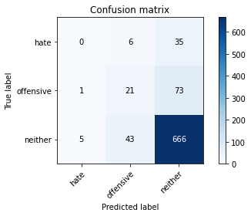

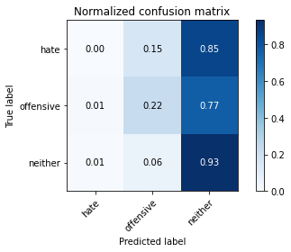

precision recall f1-score support

hate 0.00 0.00 0.00 41

offensive 0.30 0.22 0.25 95

neither 0.86 0.93 0.90 714

accuracy 0.81 850

macro avg 0.39 0.38 0.38 850

weighted avg 0.76 0.81 0.78 850

average eval_loss: 1.1682906039250367, accuracy: 0.808235294117647

5 run......

training 1 epoch...

10.615696907043457 seconds used......

1 training finished! average train loss: 0.6920870968928704

evaluating...

Confusion matrix, without normalization

[[ 0 0 41]

[ 0 0 95]

[ 0 0 714]]

Normalized confusion matrix

[[0. 0. 1.]

[0. 0. 1.]

[0. 0. 1.]]





/opt/conda/lib/python3.7/site-packages/sklearn/metrics/_classification.py:1245: UndefinedMetricWarning: Precision and F-score are ill-defined and being set to 0.0 in labels with no predicted samples. Use `zero_division` parameter to control this behavior.

_warn_prf(average, modifier, msg_start, len(result))

/opt/conda/lib/python3.7/site-packages/sklearn/metrics/_classification.py:1245: UndefinedMetricWarning: Precision and F-score are ill-defined and being set to 0.0 in labels with no predicted samples. Use `zero_division` parameter to control this behavior.

_warn_prf(average, modifier, msg_start, len(result))

/opt/conda/lib/python3.7/site-packages/sklearn/metrics/_classification.py:1245: UndefinedMetricWarning: Precision and F-score are ill-defined and being set to 0.0 in labels with no predicted samples. Use `zero_division` parameter to control this behavior.

_warn_prf(average, modifier, msg_start, len(result))

precision recall f1-score support

hate 0.00 0.00 0.00 41

offensive 0.00 0.00 0.00 95

neither 0.84 1.00 0.91 714

accuracy 0.84 850

macro avg 0.28 0.33 0.30 850

weighted avg 0.71 0.84 0.77 850

average eval_loss: 0.47388130149175955, accuracy: 0.84

training 2 epoch...

10.602661371231079 seconds used......

2 training finished! average train loss: 0.6124883610468644

evaluating...

Confusion matrix, without normalization

[[ 8 0 33]

[ 7 0 88]

[ 18 0 696]]

Normalized confusion matrix

[[0.19512195 0. 0.80487805]

[0.07368421 0. 0.92631579]

[0.02521008 0. 0.97478992]]

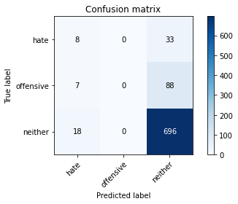

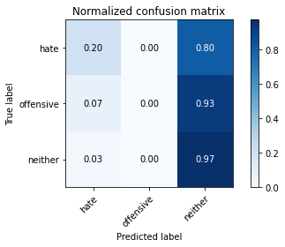

/opt/conda/lib/python3.7/site-packages/sklearn/metrics/_classification.py:1245: UndefinedMetricWarning: Precision and F-score are ill-defined and being set to 0.0 in labels with no predicted samples. Use `zero_division` parameter to control this behavior.

_warn_prf(average, modifier, msg_start, len(result))

/opt/conda/lib/python3.7/site-packages/sklearn/metrics/_classification.py:1245: UndefinedMetricWarning: Precision and F-score are ill-defined and being set to 0.0 in labels with no predicted samples. Use `zero_division` parameter to control this behavior.

_warn_prf(average, modifier, msg_start, len(result))

/opt/conda/lib/python3.7/site-packages/sklearn/metrics/_classification.py:1245: UndefinedMetricWarning: Precision and F-score are ill-defined and being set to 0.0 in labels with no predicted samples. Use `zero_division` parameter to control this behavior.

_warn_prf(average, modifier, msg_start, len(result))

precision recall f1-score support

hate 0.24 0.20 0.22 41

offensive 0.00 0.00 0.00 95

neither 0.85 0.97 0.91 714

accuracy 0.83 850

macro avg 0.36 0.39 0.38 850

weighted avg 0.73 0.83 0.77 850

average eval_loss: 0.5606750858037971, accuracy: 0.8282352941176471

training 3 epoch...

10.684033393859863 seconds used......

3 training finished! average train loss: 0.4887939556286885

evaluating...

Confusion matrix, without normalization

[[ 25 0 16]

[ 34 0 61]

[129 2 583]]

Normalized confusion matrix

[[0.6097561 0. 0.3902439 ]

[0.35789474 0. 0.64210526]

[0.18067227 0.00280112 0.81652661]]

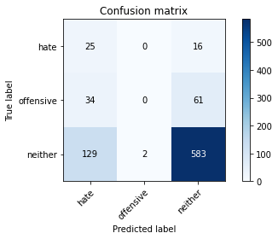

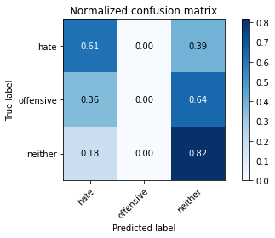

precision recall f1-score support

hate 0.13 0.61 0.22 41

offensive 0.00 0.00 0.00 95

neither 0.88 0.82 0.85 714

accuracy 0.72 850

macro avg 0.34 0.48 0.36 850

weighted avg 0.75 0.72 0.72 850

average eval_loss: 0.5901317999286707, accuracy: 0.7152941176470589

training 4 epoch...

10.5711829662323 seconds used......

4 training finished! average train loss: 0.31513068355046786

evaluating...

Confusion matrix, without normalization

[[ 12 0 29]

[ 19 4 72]

[ 50 6 658]]

Normalized confusion matrix

[[0.29268293 0. 0.70731707]

[0.2 0.04210526 0.75789474]

[0.07002801 0.00840336 0.92156863]]

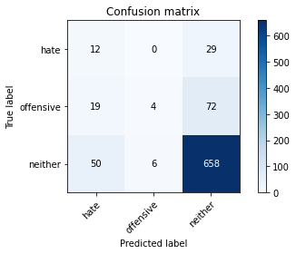

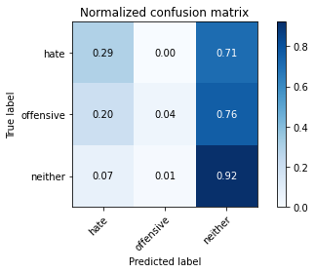

precision recall f1-score support

hate 0.15 0.29 0.20 41

offensive 0.40 0.04 0.08 95

neither 0.87 0.92 0.89 714

accuracy 0.79 850

macro avg 0.47 0.42 0.39 850

weighted avg 0.78 0.79 0.77 850

average eval_loss: 0.48283766838180464, accuracy: 0.7929411764705883

training 5 epoch...

10.597649335861206 seconds used......

5 training finished! average train loss: 0.17378575778924502

evaluating...

Confusion matrix, without normalization

[[ 10 5 26]

[ 8 17 70]

[ 32 47 635]]

Normalized confusion matrix

[[0.24390244 0.12195122 0.63414634]

[0.08421053 0.17894737 0.73684211]

[0.04481793 0.06582633 0.88935574]]

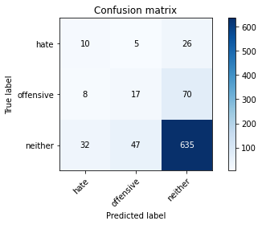

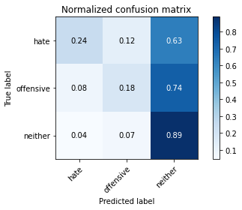

precision recall f1-score support

hate 0.20 0.24 0.22 41

offensive 0.25 0.18 0.21 95

neither 0.87 0.89 0.88 714

accuracy 0.78 850

macro avg 0.44 0.44 0.44 850

weighted avg 0.77 0.78 0.77 850

average eval_loss: 0.55373639256022, accuracy: 0.7788235294117647

training 6 epoch...

10.555159330368042 seconds used......

6 training finished! average train loss: 0.08576323693761459

evaluating...

Confusion matrix, without normalization

[[ 9 8 24]

[ 6 27 62]

[ 39 74 601]]

Normalized confusion matrix

[[0.2195122 0.19512195 0.58536585]

[0.06315789 0.28421053 0.65263158]

[0.05462185 0.10364146 0.84173669]]

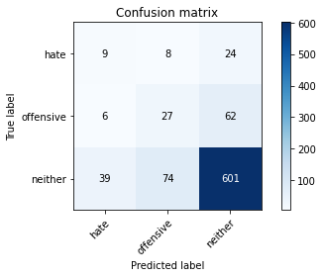

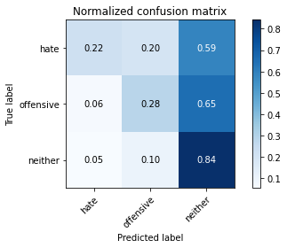

precision recall f1-score support

hate 0.17 0.22 0.19 41

offensive 0.25 0.28 0.26 95

neither 0.87 0.84 0.86 714

accuracy 0.75 850

macro avg 0.43 0.45 0.44 850

weighted avg 0.77 0.75 0.76 850

average eval_loss: 0.7194901963176076, accuracy: 0.7494117647058823

training 7 epoch...

10.566877365112305 seconds used......

7 training finished! average train loss: 0.04528023964510514

evaluating...

Confusion matrix, without normalization

[[ 2 11 28]

[ 2 20 73]

[ 12 62 640]]

Normalized confusion matrix

[[0.04878049 0.26829268 0.68292683]

[0.02105263 0.21052632 0.76842105]

[0.01680672 0.08683473 0.89635854]]

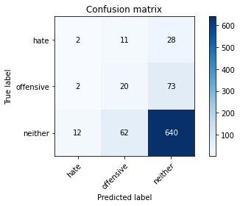

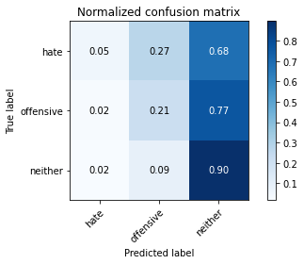

precision recall f1-score support

hate 0.12 0.05 0.07 41

offensive 0.22 0.21 0.21 95

neither 0.86 0.90 0.88 714

accuracy 0.78 850

macro avg 0.40 0.39 0.39 850

weighted avg 0.76 0.78 0.77 850

average eval_loss: 0.7781337318173068, accuracy: 0.7788235294117647

training 8 epoch...

10.552586317062378 seconds used......

8 training finished! average train loss: 0.020559840140720972

evaluating...

Confusion matrix, without normalization

[[ 3 9 29]

[ 2 19 74]

[ 13 72 629]]

Normalized confusion matrix

[[0.07317073 0.2195122 0.70731707]

[0.02105263 0.2 0.77894737]

[0.01820728 0.10084034 0.88095238]]

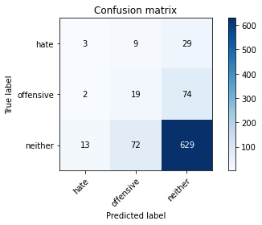

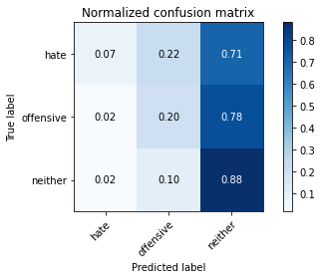

precision recall f1-score support

hate 0.17 0.07 0.10 41

offensive 0.19 0.20 0.19 95

neither 0.86 0.88 0.87 714

accuracy 0.77 850

macro avg 0.41 0.38 0.39 850

weighted avg 0.75 0.77 0.76 850

average eval_loss: 0.9078348766874283, accuracy: 0.7658823529411765

training 9 epoch...

10.558465957641602 seconds used......

9 training finished! average train loss: 0.010422417482074637

evaluating...

Confusion matrix, without normalization

[[ 7 9 25]

[ 3 26 66]

[ 24 95 595]]

Normalized confusion matrix

[[0.17073171 0.2195122 0.6097561 ]

[0.03157895 0.27368421 0.69473684]

[0.03361345 0.13305322 0.83333333]]

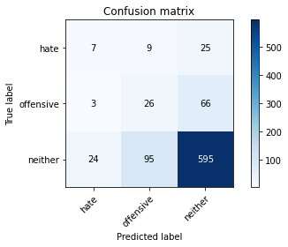

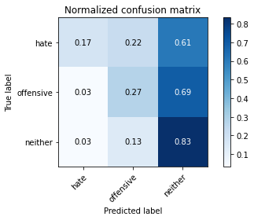

precision recall f1-score support

hate 0.21 0.17 0.19 41

offensive 0.20 0.27 0.23 95

neither 0.87 0.83 0.85 714

accuracy 0.74 850

macro avg 0.42 0.43 0.42 850

weighted avg 0.76 0.74 0.75 850

average eval_loss: 1.0170739240305455, accuracy: 0.7388235294117647

training 10 epoch...

10.585183143615723 seconds used......

10 training finished! average train loss: 0.006555655415957937

evaluating...

Confusion matrix, without normalization

[[ 5 10 26]

[ 2 30 63]

[ 20 97 597]]

Normalized confusion matrix

[[0.12195122 0.24390244 0.63414634]

[0.02105263 0.31578947 0.66315789]

[0.0280112 0.13585434 0.83613445]]

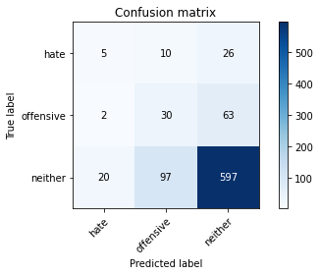

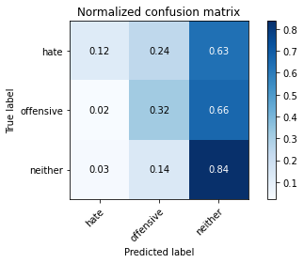

precision recall f1-score support

hate 0.19 0.12 0.15 41

offensive 0.22 0.32 0.26 95

neither 0.87 0.84 0.85 714

accuracy 0.74 850

macro avg 0.42 0.42 0.42 850

weighted avg 0.76 0.74 0.75 850

average eval_loss: 1.0391904730566366, accuracy: 0.7435294117647059

training 11 epoch...

10.568804502487183 seconds used......

11 training finished! average train loss: 0.00441340043505009

evaluating...

Confusion matrix, without normalization

[[ 3 9 29]

[ 2 31 62]

[ 11 109 594]]

Normalized confusion matrix

[[0.07317073 0.2195122 0.70731707]

[0.02105263 0.32631579 0.65263158]

[0.01540616 0.15266106 0.83193277]]

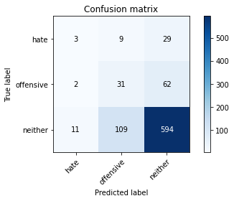

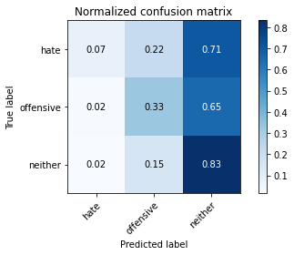

precision recall f1-score support

hate 0.19 0.07 0.11 41

offensive 0.21 0.33 0.25 95

neither 0.87 0.83 0.85 714

accuracy 0.74 850

macro avg 0.42 0.41 0.40 850

weighted avg 0.76 0.74 0.75 850

average eval_loss: 1.1294592723810808, accuracy: 0.7388235294117647

training 12 epoch...

10.600411891937256 seconds used......

12 training finished! average train loss: 0.00316306790874268

evaluating...

Confusion matrix, without normalization

[[ 1 11 29]

[ 1 23 71]

[ 9 73 632]]

Normalized confusion matrix

[[0.02439024 0.26829268 0.70731707]

[0.01052632 0.24210526 0.74736842]

[0.01260504 0.1022409 0.88515406]]

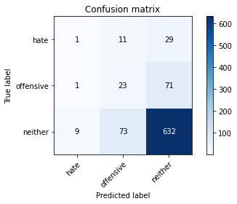

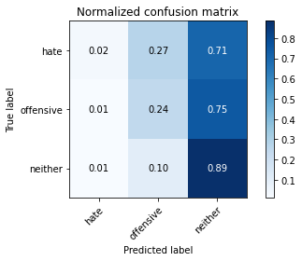

precision recall f1-score support

hate 0.09 0.02 0.04 41

offensive 0.21 0.24 0.23 95

neither 0.86 0.89 0.87 714

accuracy 0.77 850

macro avg 0.39 0.38 0.38 850

weighted avg 0.75 0.77 0.76 850

average eval_loss: 1.1086804530008691, accuracy: 0.7717647058823529

training 13 epoch...

10.535755157470703 seconds used......

13 training finished! average train loss: 0.006469755587526239

evaluating...

Confusion matrix, without normalization

[[ 6 20 15]

[ 4 53 38]

[ 24 133 557]]

Normalized confusion matrix

[[0.14634146 0.48780488 0.36585366]

[0.04210526 0.55789474 0.4 ]

[0.03361345 0.18627451 0.78011204]]

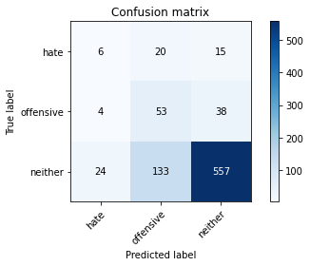

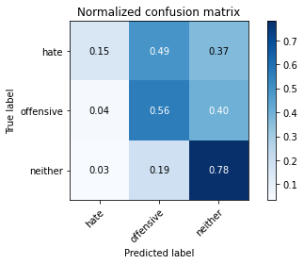

precision recall f1-score support

hate 0.18 0.15 0.16 41

offensive 0.26 0.56 0.35 95

neither 0.91 0.78 0.84 714

accuracy 0.72 850

macro avg 0.45 0.49 0.45 850

weighted avg 0.80 0.72 0.75 850

average eval_loss: 1.3652414338484535, accuracy: 0.7247058823529412

training 14 epoch...

10.663952350616455 seconds used......

14 training finished! average train loss: 0.008352310393596641

evaluating...

Confusion matrix, without normalization

[[ 4 8 29]

[ 3 19 73]

[ 27 56 631]]

Normalized confusion matrix

[[0.09756098 0.19512195 0.70731707]

[0.03157895 0.2 0.76842105]

[0.03781513 0.07843137 0.8837535 ]]

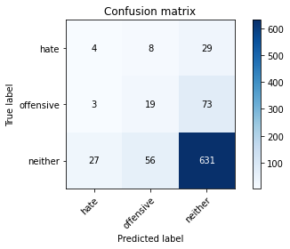

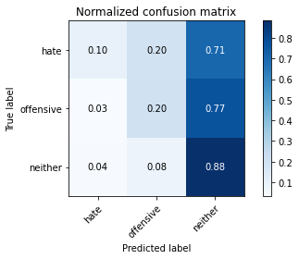

precision recall f1-score support

hate 0.12 0.10 0.11 41

offensive 0.23 0.20 0.21 95

neither 0.86 0.88 0.87 714

accuracy 0.77 850

macro avg 0.40 0.39 0.40 850

weighted avg 0.75 0.77 0.76 850

average eval_loss: 1.0670458652322088, accuracy: 0.7694117647058824

training 15 epoch...

10.506463289260864 seconds used......

15 training finished! average train loss: 0.0049365838286646

evaluating...

Confusion matrix, without normalization

[[ 4 19 18]

[ 3 44 48]

[ 18 128 568]]

Normalized confusion matrix

[[0.09756098 0.46341463 0.43902439]

[0.03157895 0.46315789 0.50526316]

[0.02521008 0.17927171 0.79551821]]

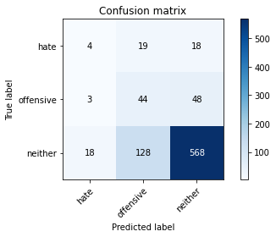

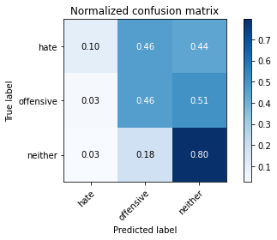

precision recall f1-score support

hate 0.16 0.10 0.12 41

offensive 0.23 0.46 0.31 95

neither 0.90 0.80 0.84 714

accuracy 0.72 850

macro avg 0.43 0.45 0.42 850

weighted avg 0.79 0.72 0.75 850

average eval_loss: 1.333860269643442, accuracy: 0.7247058823529412

training 16 epoch...

10.530810117721558 seconds used......

16 training finished! average train loss: 0.01254800841695844

evaluating...

Confusion matrix, without normalization

[[ 2 6 33]

[ 2 14 79]

[ 9 25 680]]

Normalized confusion matrix

[[0.04878049 0.14634146 0.80487805]

[0.02105263 0.14736842 0.83157895]

[0.01260504 0.03501401 0.95238095]]

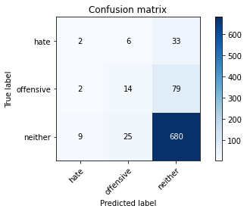

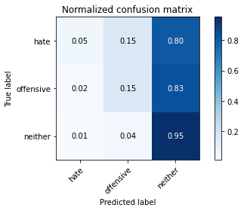

precision recall f1-score support

hate 0.15 0.05 0.07 41

offensive 0.31 0.15 0.20 95

neither 0.86 0.95 0.90 714

accuracy 0.82 850

macro avg 0.44 0.38 0.39 850

weighted avg 0.76 0.82 0.78 850

average eval_loss: 1.0418120418207553, accuracy: 0.8188235294117647

training 17 epoch...

10.494667053222656 seconds used......

17 training finished! average train loss: 0.024411146889906376

evaluating...

Confusion matrix, without normalization

[[ 5 13 23]

[ 4 38 53]

[ 23 85 606]]

Normalized confusion matrix

[[0.12195122 0.31707317 0.56097561]

[0.04210526 0.4 0.55789474]

[0.03221289 0.11904762 0.8487395 ]]

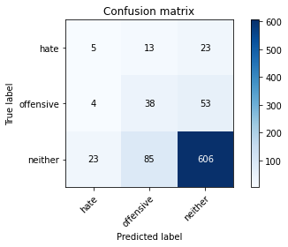

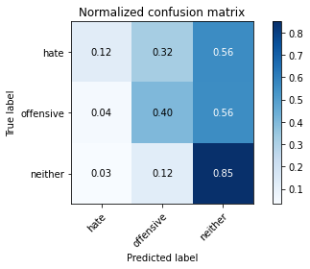

precision recall f1-score support

hate 0.16 0.12 0.14 41

offensive 0.28 0.40 0.33 95

neither 0.89 0.85 0.87 714

accuracy 0.76 850

macro avg 0.44 0.46 0.44 850

weighted avg 0.79 0.76 0.77 850

average eval_loss: 0.9577124967174822, accuracy: 0.7635294117647059

training 18 epoch...

10.533679246902466 seconds used......

18 training finished! average train loss: 0.004138830767568344

evaluating...

Confusion matrix, without normalization

[[ 5 11 25]

[ 3 30 62]

[ 17 70 627]]

Normalized confusion matrix

[[0.12195122 0.26829268 0.6097561 ]

[0.03157895 0.31578947 0.65263158]

[0.02380952 0.09803922 0.87815126]]

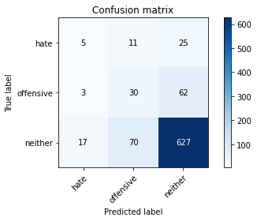

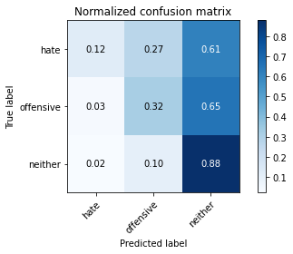

precision recall f1-score support

hate 0.20 0.12 0.15 41

offensive 0.27 0.32 0.29 95

neither 0.88 0.88 0.88 714

accuracy 0.78 850

macro avg 0.45 0.44 0.44 850

weighted avg 0.78 0.78 0.78 850

average eval_loss: 0.9759602972203433, accuracy: 0.7788235294117647

training 19 epoch...

10.529686450958252 seconds used......

19 training finished! average train loss: 0.0014354211860336363

evaluating...

Confusion matrix, without normalization

[[ 5 11 25]

[ 3 33 59]

[ 17 77 620]]

Normalized confusion matrix

[[0.12195122 0.26829268 0.6097561 ]

[0.03157895 0.34736842 0.62105263]

[0.02380952 0.10784314 0.86834734]]

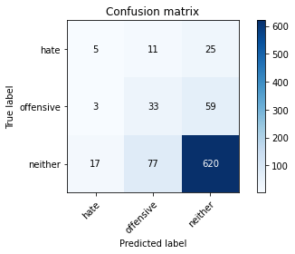

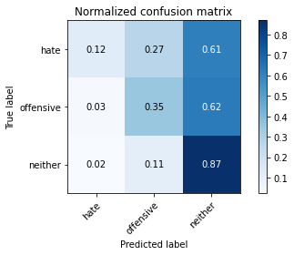

precision recall f1-score support

hate 0.20 0.12 0.15 41

offensive 0.27 0.35 0.31 95

neither 0.88 0.87 0.87 714

accuracy 0.77 850

macro avg 0.45 0.45 0.44 850

weighted avg 0.78 0.77 0.78 850

average eval_loss: 1.0405297698385385, accuracy: 0.7741176470588236

training 20 epoch...

10.50829029083252 seconds used......

20 training finished! average train loss: 0.0010708054608235566

evaluating...

Confusion matrix, without normalization

[[ 4 10 27]

[ 3 31 61]

[ 14 72 628]]

Normalized confusion matrix

[[0.09756098 0.24390244 0.65853659]

[0.03157895 0.32631579 0.64210526]

[0.01960784 0.10084034 0.87955182]]

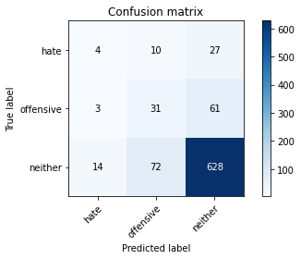

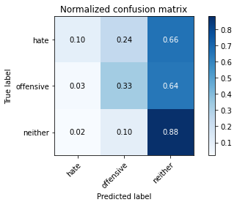

precision recall f1-score support

hate 0.19 0.10 0.13 41

offensive 0.27 0.33 0.30 95

neither 0.88 0.88 0.88 714

accuracy 0.78 850

macro avg 0.45 0.43 0.44 850

weighted avg 0.78 0.78 0.78 850

average eval_loss: 1.052758960770768, accuracy: 0.78

add Codeadd Markdown